### तमसो मा ज्योतिर्गमय

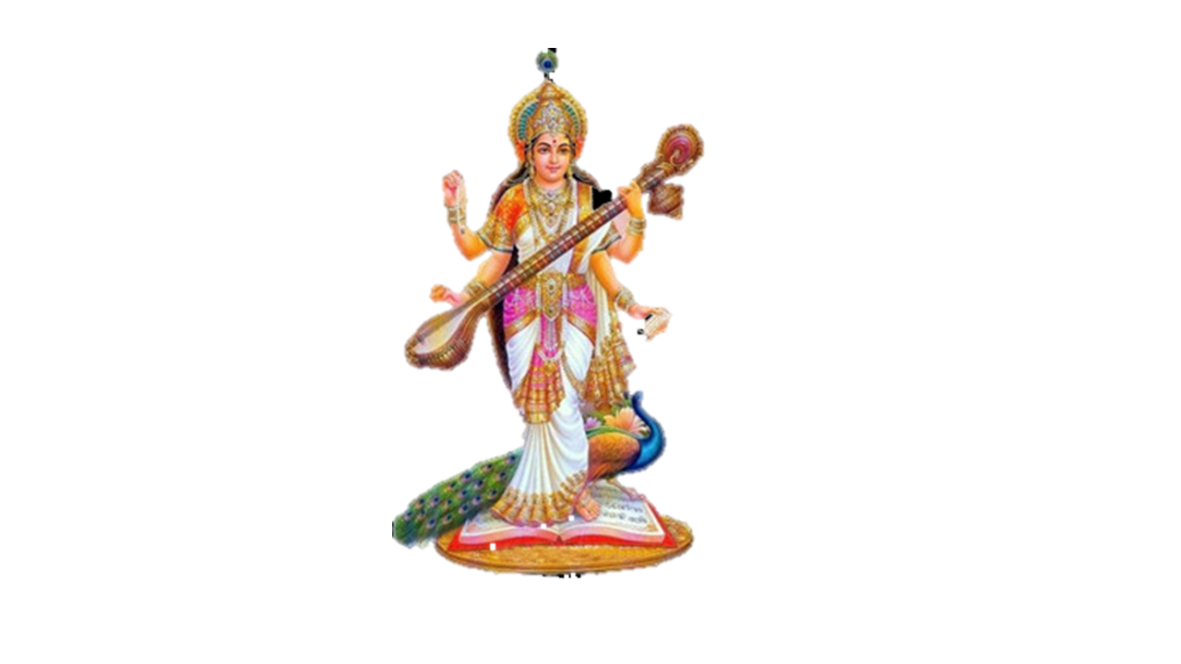

**या कुन्देन्दु तुषार हार धवला या शुभ्र वस्त्रावृता |  
या वीणा वर दण्ड मण्डितकरा, या श्वेत पद्मासना ||  
या ब्रह्माच्युत शंकर प्रभृतिभिर्देवैः,सदा वन्दिता |  
सा मां पातु सरस्वती भगवती, निःशेषजाड्यापहा ||**

VEER KUNWAR SINGH UNIVERSITY

ARA



S.V.P COLLEGE , BHABUA

(KAIMUR)

PROJECT REPORT

BCA 6TH SEMESTER

Restaurant Management System

GUIDED DEVELOPED BY

Mr. Ashutosh Kumar Singh Amarjeet Sharma

(MCA) Roll No.:194010900011

S.V.P COLLEGE BHABUA Reg. No.:19401651438

**&**

Wasim Khan

Roll No.:194010900051

Reg. No.:19401651480

**Certificate**

This is to certify that Amarjeet sharma & Wasim Khan has Successfully Completed. The document is benefited copy of the original document. This Project is developed under the guidance by **Mr. Ashutosh Kumar Singh** for the final semester of B.C.A course of S.V.P College Bhabua.

**Mr. Ashutosh Kumar Singh**

Project Co-Ordinator

**About University**

Veer Kunwar Singh University

Veer Kunwar Singh University named after the well known national hero and distinguished freedom fighter of 1857 was established on 22nd October 1992,October 1992 with its Head Quarter at Ara, under the Bihar University Act 1976 [as amendment Act 9 of 1992]. Its jurisdiction covers four western educationally backward districts of Bihar [ Bhojpur, Buxar, Kaimur, & Rohtas]. It serves the educational needs of more than one crore population of these districts through its 20 University Post Graduate Departments, 17 Constituent Degree Colleges, three Law Colleges and forty seven affiliated Degree Colleges. This University has already been enlisted in the list of recognised Universities under Section 2(f) of the U.G.C Act. All its 17 Constituent Colleges and one affiliated College are receiving financial assistance from U.G.C by virtue of being Constituent/Affiliated Colleges of erstwhile Magadh University, Bodh-Gaya Bihar.

Keeping in view the inadequacies of the facilities for Higher Education and Research in this region Veer Kunwar Singh University has introduced new courses like B.C.A, B.Sc.(IT) B.B.A, B.Sc (Bio-Technology), M.Sc.(Env. Science), M.A. (P.M.I.R) ad Bachelor of Bank Science and Information Science from the academic session 2006-07, various U.G.C , the constituent and affiliated college have introduced Certificate /Diploma /Advanced Diploma programme such as D.C.A Rural Management, Tissue, culture, Fisheries, hospital waste Management , Fashion designing E-commerce and computer hardware maintenance. The need for strengthening its extension activities, the University has submitted a proposal to the State Government.

For improving the quality of Governance at grass root level, the University in anxious to introduce Traning Programme for the elected representatives of Panchayati Raj and public functionaries with Panchayati Raj in collaboration with the State Government.

**CURRICULUM-VITAE**

**ASHUTOSH KUMAR SINGH**

Vill+Post-Mokari, P.s-Bhabua

Dist-Kaimur,Bihar(821101)

Mob-9771952099

Email:ashumaxz@gmail.com

**ASHUTOSH KUMAR SINGH**

**Career Objective:**

To Enhance My personal skill through serving your esteemed organization .

**Strength:**

To Sincerity, positive attitude, punctual, Strong commitment towards task

Undertaken.

**Academic Qualification:**

: Post Graduation(MCA) SMU, Gangtok in 2008

: Graduation From V.K. Singh University, Ara in 2004.

: 10+2th From U.P Board From UP in 2001.

: 10th From B.S.E.B, BHABUA in 1999.

**Technical Qualification:**

* Done Three year advance Diploma in computing from Edexcel Foundation London(2001-2004).

**Experience:**

: Working from one year in Gov. B.S.S.S. Dr. Ambedkar Nagar No-2

Sect-IV New Delhi at MIS Project (2004 to 2007).

: Working from S.V.P College Bhabua as a Computer Teacher in BCA

Dept. (2007 to Till Date).

**Personal Details:**

Father’s Name : Shri Shrikant Singh

Date Of Birth : 23/01/1985

Nationality : Indian

Sex : Male

Marital Status : Single

Hobbies : Traveling, listening song, reading Newspaper.

Place : Bhabua. …………………………….

**Signature**

Acknowledgement

We are very much obliged to our teaching faculty **Mr. Ashutosh Kumar Singh** along with other faculty members who have helped us in every step and stages during the development process of the project and on time.

We are very thankful to him for providing us library, faculty, lab instructor as well as enough time to complete the project.

Last but not least we thank to all those who have helped us directly or indirectly in completion of this project.

Thank you so much sir for showing us a right path to enhance and explore our career.

Thank You Sir…

**Index**

|  |  |  |
| --- | --- | --- |
| **S .No.** | **Title** | **Page No.** |
| **1.** | **Introduction** | **8** |
| **2.** | **Abstract** | **9** |
| **3.** | **Objective** | **10-11** |
| **4.** | **Accessing Database** | **12-16** |
| **5.** | **Software Description** | **17** |
| **6.** | **Data Tables** | **18-19** |
| **7.** | **Data Structure** | **20** |
| **8.** | **Data Flow Diagram** | **21-22** |
| **9.** | **ER-Diagram** | **23-26** |
| **10.** | **Source Code & Design** | **27-170** |
| **11.** | **Module Description** | **171** |
| **12.** | **Tools Languages Used** | **172** |
| **13.** | **Software Environment** | **173** |
| **14.** | **Further scope of the project** | **174** |
| **15.** | **Conclusion** | **175** |
| **16.** | **References** | **176** |

INTRODUCTION

The **Restaurant Management System** is to generalize and simplify the monthly or day to day activities of café like food activities ,check in of new customer, check out of customer , assigning a food according to customer requirement , and finally compute the bill etc.

Which has to be performed repeatedly on regular basis. To provide efficient, fast, reliable and user-friendly system is the basic motto behind this exercise. And show the café food choice, order food.

The main aim of the entire activity is to automate the process of day to day activities of café like food choice, A new customer, assign a food according to customer’s demand, checkout of a computer and releasing the food and finally compute the bill etc.

**ABSTRACT**

A Restaurant Management System” is developed using connectivity between MySql and Java.

The proper “Restaurant Management System” is implemented to reduce the manual work and enhances the accuracy of work in a restaurant.

We propose to build a software project that can efficiently handle and manage various activities of a restaurant and all activities will be happening under the supervision of the administrator. Hence the project is developed proficiently to help restaurant owner’s automata, their business operations. The standalone System which we deployed can be accessible by both customer and manager .

In this management system we will provide an application that can be viewed by the customers to know the particular restaurant. There will be different items available in a restaurant many customers will be coming at different time for having food, they will be eating different items available in the restaurant .

Restaurant owner has to maintain records off each sales and purchase.

The system will save time and will be easy to use when compared to normal work which will be done in papers.

**Objective**

Creation of software is ideal solution for the hospitality industry that can be used at café, motels, resorts guest houses, suits, and breakfast operations.

The software aims at creating an Resturant management system which can be used by customers to order café food.

Users can check the status of food and facilities.

The administrator will know the details of order and daily income. The software avoid manual and repetitive work and provide real time information of availability of foods.

This software allow user to search and order a café food over at any time from anywhere. This software also improve the decision making.

This software covers various aspects in Resturant management system and always performs user friendly. It helps to ease staff with facilities for order process. It saves the time which was wasting more in manual work.

A Restaurant management system application where manager can add/view/delete customers

Details who visited restaurant and daily consumed items add customer can view this application in restaurant (if we made it accessible) and lookup recepies and about the particular restaurant.

**Users of the Application:-**

1. Admin(Manager)
2. Customer

**Functional Requirements:-**

* **Manager**
* Can login to do following activities.
* Can add/view/delete customer details.
* Can add/view new item to menu.
* Can view/update daily consumed food.
* **Customer**
* Can view menu.
* Can see the other details(history, contact, address) of restaurant.

**Accessing Databases**

Data in the following databases can be accessed in Mysql workbench.

**JDBC :**

Java database connectivity (JDBC) is the java Soft specification of a standard application programming interface (API) that allows java program to access database management system. The JDBC API consists of a set of interfaces and classes written in the java programming language.

Using these standard interfaces and classes, programmers can write applications that connect to database, send queries written in structured query language (SQL), and process the results.

Since JDBC is a standard specification, one java program that uses the JDBC API can connect to any database management system(DBMS), as long as a driver exists for that particular DBMS.

**Jet Database :-**

Database Created using the jet database engine. Microsoft Access also uses the jet database engine as its data manager eomponent.

**MySql:-**

Mysql (“My S-Q-L”, officially, but also called “my sequel”) is (as of July 2022) the world’s second most widely used open-source relational database management system(RDBMS). It is named after co-founder Michael wideness daughter, my.the SQl phrase stands for structured query language. The mySql development project has made its source code available under the terms of the GNU general public license, as sell as under a variety of proprietary agreements. MySQL AB, now owned by Oracle corporation. MySQL is a popular choice of database for use in web applications, and is a central component of the widely used LAMP open source web application software stack (and other ‘AMP’ stack). LAMP is an acronym for “Linux, Apache, MySQl, Perl/PHP/Python.”

Free-software-open source projects that require a full-featured database management system often use MySQL. For commercial use, several paid editions are available, and offer additional functionality. Applications which use MySQL database.

**HTML:-**

HTML or Hyper Text Markup Language is the main markup

language for creating web pages and other information that can be displayed in a web browser.HTML is written in the form of HTML elements consisting of tags enclosed in angle brackets (like ), within the web page content. HTML tags most commonly come in pairs like <h1> and <h1/> although some tags represent empty elements and so are unpaired, for example **Error! Filename not specified.**. The first tag in a pair is the start tag, and the second tag is the end tag (they are also called opening tags and closing tags). In between these tags web designers can add text, further tags, comments and other types of text-based content. The purpose of a web browser is to read HTML documents and compose them into visible or audible web pages. The browser does not display the HTML tags, but uses the tags to interpret the content of the page.HTML elements form the building blocks of all websites. HTML allows images and objects to be embedded and can be used to create interactive forms. It provides a means to create structured documents by denoting structural semantics for text such as headings, paragraphs, lists, links, quotes and other items. It can embed scripts written in languages such as JavaScript which affect the behavior of HTML web pages.

**CSS:-**

Cascading Style Sheets (CSS) is a style sheet

language used for describing the look and formatting of a document written in a markup language. While most often used to style web pages and interfaces written in HTML and XHTML, the language can be applied to any kind of XML document, including plain XML, SVG and XUL. CSS is a cornerstone specification of the web and almost all web pages use CSS style sheets to describe their presentation.CSS is designed primarily to enable the separation of document content from document presentation, including elements such as the layout, colors, and fonts. This separation can improve content accessibility, provide more flexibility and control in the specification of presentation characteristics, enable multiple pages to share formatting, and reduce complexity and repetition in the structural content (such as by allowing for table less web design).CSS can also allow the same markup page to be presented in different styles for different rendering methods, such as on-screen, in print, by voice (when read out by a speech-based browser or screen reader) and on Braille-based, tactile devices. It can also be used to allow the web page to display differently depending on the screen size or device on which it is being viewed. While the author of a document typically links that document to a CSS file, readers can use a different style sheet, perhaps one on their own computer, to override the one the author has specified. However if the author or the reader did not link the document to a specific style sheet the default style of the browser will be applied.CSS specifies a priority scheme to determine which style rules apply if more than one rule matches against a particular element. In this so-called cascade, priorities or weights are calculated and assigned to rules, so that the results are predictable.

**JAVA SCRIPT:-**

JavaScript (JS) is a dynamic computer programming .

language. It is most commonly used as part of web browsers, whose implementations allow client-side scripts to interact with the user, control the browser, communicate asynchronously, and alter the document content that is displayed. It is also being used in server-side programming, game development and the creation of desktop and mobile applications. JavaScript is a prototype-based scripting language with dynamic typing and has firstclass functions. Its syntax was influenced by C. JavaScript copies many names and naming conventions from Java, but the two languages are otherwise unrelated and have very different semantics. The key design principles within JavaScript are taken from the Self and Scheme programming languages. It is a multiparadigm language, supporting object-oriented, imperative, and functional programming styles. The application of JavaScript to use outside of web pages—for example, in PDF documents, site-specific browsers, and desktop widgets—is also significant. Newer and faster JavaScript VMs and platforms built upon them (notably Node.js) have also increased the popularity of JavaScript for server-side web applications. On the client side, JavaScript was traditionally implemented as an interpreted language but just-in-time compilation is now performed by recent (post-2012) browsers.

**Database:-**

Java Application

JDBC Driver Manager

Vendor supplied JDBC driver

JDBC/ODBC

bridge

ODBC driver

Database

Database

**Software Description**

**Development phase:-**

In the development phase, the system is constructed to fulfil the requirements outlined in the design phase.

Development phase activities include preparing manuals and training customers, writing and testing computer programs are part. At the conclusion of the development phase, the system is ready to be put into use.

This phase includes with a presentation of the complete system for acceptance by the user, at management review meeting. To Ten at twenty days, finally the testing of the computer programs may take twenty more days.

**Processor:-**

A processor is a piece of hardware is capable of executing programs. A name is required for each processor, there are no particular constraints upon processor names, because they denote hardware not software entities.

**Devices:-**

A device is a piece of hardware incapable of executing programs. A name is required for each device. There are no particular constraints over device names and in fact their names may be quite generic.

**Connections:-**

Processors and devices must communication with one another. Using undirected line we may indicate the connections between a device and a processor.

A connection may also represent more indirect coupling such as satellite to ground communications. connections are usually considered to be bi-directional, although if a particular connection is unidirectional, an arrow may be added to show the direction. Each connection may include an optional label that names the connections.

**Data Tables**

**User:-**

|  |  |
| --- | --- |
| Id | Int null primary key auto_increment |
| Name | Varchar |
| Email | Varcha |
| Mobile | Varchar |
| Address | Varchar |
| Password | Varchar |
| Security Question | Varchar |
| Answer | Varchar |
| Status | Varchar |
|  |  |

**Category:-**

|  |  |
| --- | --- |
| Id | Int null primary key auto_increment |
| Name | Varchar |

**Product:-**

|  |  |
| --- | --- |
| Id | Int null primary key auto_increment |
| Name | Varchar |
| Category | Varchar |
| Price | Int |

**Bill:-**

|  |  |
| --- | --- |
| Id | Int null primary key auto_increment |
| Name | Varchar |
| Mobile Number | Varchar |
| Email | Varchar |
| Date | Date |
| Total | Varchar |
| Created by | Varchar |

**Data Structure**

Here Mysql is used as back end. All tables are made in access. In this project Restaurant Management System , There are Four tables present to maintain the record. These tables are :-

1.User

2. Product

3. Category

4.Bill

**Data Flow Diagram Login Page:-**

Customer/Admin Login Page



User/Admin



Enter

username or Password



Verify Users



User

Database

**Data Flow Diagram Home Page:-**



IF



Home Page



Manage

Product



Login

Database



New

Product



Place

Order

Items



Update

Product

Items

Bill



Produc t

Database



Product

Database



Login

Table



AVBL



IF NO

Product

-

**ER-Diagram**

**User:-**

User

**Forgot Pasword :-**

Forgot Password

**Login :-**

Login

**Product:-**

Product

**Category :-**

Category

**Bill:-**

Bill

**Restaurant Management System :-**

Admin

User Login

User

Has

Permission

Category

Manage

Bill

Product

Has

Order

**Source Code & Design**

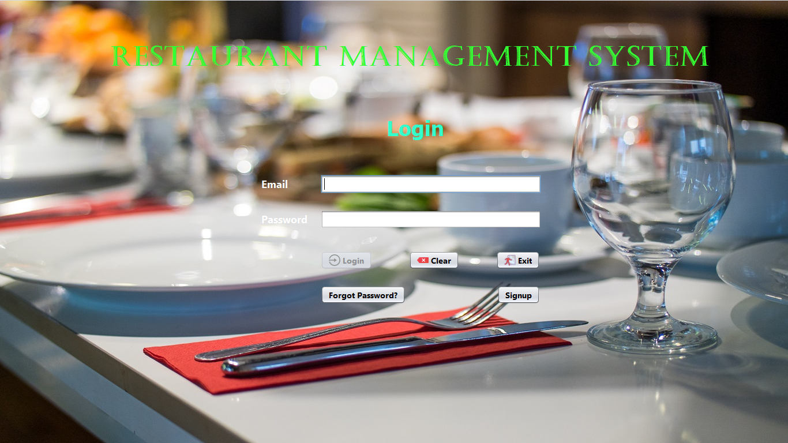

Figure no.:-1

**Login :-**

/*

* Click nbfs://nbhost/SystemFileSystem/Templates/Licenses/license-default.txt to change this license

* Click nbfs://nbhost/SystemFileSystem/Templates/GUIForms/JFrame.java to edit this template

*/

package cafe.management.system;

import javax.swing.JOptionPane;

import model.User;

import dao.UserDao;

import javax.swing.ImageIcon;

/**

*

* @author Amarjeet

*/

public class Login extends javax.swing.JFrame {

public String emailPattern="^[a-zA-Z0-9]+[@]+[a-zA-Z0-9]+[.]+[a-zA-Z0-9]+$";

/**

* Creates new form Login

*/

public Login() {

initComponents();

btnLogin.setEnabled(false);

}

public void clear()

{

txtEmail.setText("");

txtPassword.setText("");

btnLogin.setEnabled(false);

}

public void validateFields()

{

String email=txtEmail.getText();

String password=txtPassword.getText();

if(email.matches(emailPattern)&& !password.equals(""))

{

btnLogin.setEnabled(true);

}

else

{

btnLogin.setEnabled(false);

}

}

/**

* This method is called from within the constructor to initialize the form.

* WARNING: Do NOT modify this code. The content of this method is always

* regenerated by the Form Editor.

*/

@SuppressWarnings("unchecked")

// <editor-fold defaultstate="collapsed" desc="Generated Code">

private void initComponents() {

jLabel1 = new javax.swing.JLabel();

jLabel2 = new javax.swing.JLabel();

txtEmail = new javax.swing.JTextField();

jLabel3 = new javax.swing.JLabel();

txtPassword = new javax.swing.JPasswordField();

btnLogin = new javax.swing.JButton();

btnClear = new javax.swing.JButton();

btnExit = new javax.swing.JButton();

btnForgotPassword = new javax.swing.JButton();

btnSignup = new javax.swing.JButton();

jLabel5 = new javax.swing.JLabel();

jLabel4 = new javax.swing.JLabel();

setDefaultCloseOperation(javax.swing.WindowConstants.EXIT_ON_CLOSE);

setUndecorated(true);

getContentPane().setLayout(new org.netbeans.lib.awtextra.AbsoluteLayout());

jLabel1.setFont(new java.awt.Font("Tahoma", 1, 36)); // NOI18N

jLabel1.setForeground(new java.awt.Color(51, 255, 204));

jLabel1.setText("Login");

getContentPane().add(jLabel1, new org.netbeans.lib.awtextra.AbsoluteConstraints(670, 200, 110, -1));

jLabel2.setFont(new java.awt.Font("Segoe UI", 1, 18)); // NOI18N

jLabel2.setForeground(new java.awt.Color(255, 255, 255));

jLabel2.setText("Email");

getContentPane().add(jLabel2, new org.netbeans.lib.awtextra.AbsoluteConstraints(453, 306, -1, -1));

txtEmail.setFont(new java.awt.Font("Segoe UI", 1, 14)); // NOI18N

txtEmail.addKeyListener(new java.awt.event.KeyAdapter() {

public void keyReleased(java.awt.event.KeyEvent evt) {

txtEmailKeyReleased(evt);

}

});

getContentPane().add(txtEmail, new org.netbeans.lib.awtextra.AbsoluteConstraints(556, 303, 382, -1));

jLabel3.setFont(new java.awt.Font("Segoe UI", 1, 18)); // NOI18N

jLabel3.setForeground(new java.awt.Color(255, 255, 255));

jLabel3.setText("Password");

getContentPane().add(jLabel3, new org.netbeans.lib.awtextra.AbsoluteConstraints(453, 367, -1, -1));

txtPassword.setFont(new java.awt.Font("Segoe UI", 1, 14)); // NOI18N

txtPassword.addKeyListener(new java.awt.event.KeyAdapter() {

public void keyReleased(java.awt.event.KeyEvent evt) {

txtPasswordKeyReleased(evt);

}

});

getContentPane().add(txtPassword, new org.netbeans.lib.awtextra.AbsoluteConstraints(556, 364, 382, -1));

btnLogin.setFont(new java.awt.Font("Segoe UI", 1, 14)); // NOI18N

btnLogin.setIcon(new javax.swing.ImageIcon(getClass().getResource("/image/login.png"))); // NOI18N

btnLogin.setText("Login");

btnLogin.addActionListener(new java.awt.event.ActionListener() {

public void actionPerformed(java.awt.event.ActionEvent evt) {

btnLoginActionPerformed(evt);

}

});

getContentPane().add(btnLogin, new org.netbeans.lib.awtextra.AbsoluteConstraints(556, 435, -1, -1));

btnClear.setFont(new java.awt.Font("Segoe UI", 1, 14)); // NOI18N

btnClear.setIcon(new javax.swing.ImageIcon(getClass().getResource("/image/clear.png"))); // NOI18N

btnClear.setText("Clear");

btnClear.addActionListener(new java.awt.event.ActionListener() {

public void actionPerformed(java.awt.event.ActionEvent evt) {

btnClearActionPerformed(evt);

}

});

getContentPane().add(btnClear, new org.netbeans.lib.awtextra.AbsoluteConstraints(709, 435, -1, -1));

btnExit.setFont(new java.awt.Font("Segoe UI", 1, 14)); // NOI18N

btnExit.setIcon(new javax.swing.ImageIcon(getClass().getResource("/image/exit small.png"))); // NOI18N

btnExit.setText("Exit");

btnExit.addActionListener(new java.awt.event.ActionListener() {

public void actionPerformed(java.awt.event.ActionEvent evt) {

btnExitActionPerformed(evt);

}

});

getContentPane().add(btnExit, new org.netbeans.lib.awtextra.AbsoluteConstraints(860, 435, -1, -1));

btnForgotPassword.setFont(new java.awt.Font("Segoe UI", 1, 14)); // NOI18N

btnForgotPassword.setText("Forgot Password?");

btnForgotPassword.addActionListener(new java.awt.event.ActionListener() {

public void actionPerformed(java.awt.event.ActionEvent evt) {

btnForgotPasswordActionPerformed(evt);

}

});

getContentPane().add(btnForgotPassword, new org.netbeans.lib.awtextra.AbsoluteConstraints(556, 495, -1, -1));

btnSignup.setFont(new java.awt.Font("Segoe UI", 1, 14)); // NOI18N

btnSignup.setText("Signup");

btnSignup.addActionListener(new java.awt.event.ActionListener() {

public void actionPerformed(java.awt.event.ActionEvent evt) {

btnSignupActionPerformed(evt);

}

});

getContentPane().add(btnSignup, new org.netbeans.lib.awtextra.AbsoluteConstraints(862, 495, -1, -1));

jLabel5.setFont(new java.awt.Font("Castellar", 1, 48)); // NOI18N

jLabel5.setForeground(new java.awt.Color(51, 255, 51));

jLabel5.setText("Restaurant Management System ");

getContentPane().add(jLabel5, new org.netbeans.lib.awtextra.AbsoluteConstraints(190, 70, -1, -1));

jLabel4.setIcon(new javax.swing.ImageIcon(getClass().getResource("/image/Resturant.jpg"))); // NOI18N

getContentPane().add(jLabel4, new org.netbeans.lib.awtextra.AbsoluteConstraints(0, 0, 1370, 770));

pack();

}// </editor-fold>

private void btnLoginActionPerformed(java.awt.event.ActionEvent evt) {

// TODO add your handling code here:

String email=txtEmail.getText();

String password=txtPassword.getText();

User user=null;

user=UserDao.login(email, password);

if(user==null)

JOptionPane.showMessageDialog(null, "<html><b style=\"color:red\">Incorrect Username or Password</b></html>","Message",JOptionPane.ERROR_MESSAGE);

else

{

if(user.getStatus().equals("false"))

{

ImageIcon icon=new ImageIcon("src/popfIcon/wait.png");

JOptionPane.showMessageDialog(null, "<html><b>Wait for Admin Approval</b></html>","Message",JOptionPane.INFORMATION_MESSAGE,icon);

clear();

}

if(user.getStatus().equals("true"))

{

setVisible(false);

new Home(email).setVisible(true);

}

}

}

private void btnExitActionPerformed(java.awt.event.ActionEvent evt) {

// TODO add your handling code here:

int a=JOptionPane.showConfirmDialog(null, "Do you really want to close Application","Select",JOptionPane.YES_NO_OPTION);

if(a==0)

{

System.exit(0);

}

}

private void txtEmailKeyReleased(java.awt.event.KeyEvent evt) {

// TODO add your handling code here:

validateFields();

}

private void txtPasswordKeyReleased(java.awt.event.KeyEvent evt) {

// TODO add your handling code here:

validateFields();

}

private void btnClearActionPerformed(java.awt.event.ActionEvent evt) {

// TODO add your handling code here:

clear();

}

private void btnSignupActionPerformed(java.awt.event.ActionEvent evt) {

// TODO add your handling code here:

setVisible(false);

new signup().setVisible(true);

}

private void btnForgotPasswordActionPerformed(java.awt.event.ActionEvent evt) {

// TODO add your handling code here:

setVisible(false);

new ForgotPassword().setVisible(true);

}

/**

* @param args the command line arguments

*/

public static void main(String args[]) {

/* Set the Nimbus look and feel */

//<editor-fold defaultstate="collapsed" desc=" Look and feel setting code (optional) ">

/* If Nimbus (introduced in Java SE 6) is not available, stay with the default look and feel.

* For details see http://download.oracle.com/javase/tutorial/uiswing/lookandfeel/plaf.html

*/

try {

for (javax.swing.UIManager.LookAndFeelInfo info : javax.swing.UIManager.getInstalledLookAndFeels()) {

if ("Nimbus".equals(info.getName())) {

javax.swing.UIManager.setLookAndFeel(info.getClassName());

break;

}

}

} catch (ClassNotFoundException ex) {

java.util.logging.Logger.getLogger(Login.class.getName()).log(java.util.logging.Level.SEVERE, null, ex);

} catch (InstantiationException ex) {

java.util.logging.Logger.getLogger(Login.class.getName()).log(java.util.logging.Level.SEVERE, null, ex);

} catch (IllegalAccessException ex) {

java.util.logging.Logger.getLogger(Login.class.getName()).log(java.util.logging.Level.SEVERE, null, ex);

} catch (javax.swing.UnsupportedLookAndFeelException ex) {

java.util.logging.Logger.getLogger(Login.class.getName()).log(java.util.logging.Level.SEVERE, null, ex);

}

//</editor-fold>

/* Create and display the form */

java.awt.EventQueue.invokeLater(new Runnable() {

public void run() {

new Login().setVisible(true);

}

});

}

// Variables declaration - do not modify

private javax.swing.JButton btnClear;

private javax.swing.JButton btnExit;

private javax.swing.JButton btnForgotPassword;

private javax.swing.JButton btnLogin;

private javax.swing.JButton btnSignup;

private javax.swing.JLabel jLabel1;

private javax.swing.JLabel jLabel2;

private javax.swing.JLabel jLabel3;

private javax.swing.JLabel jLabel4;

private javax.swing.JLabel jLabel5;

private javax.swing.JTextField txtEmail;

private javax.swing.JPasswordField txtPassword;

// End of variables declaration

}

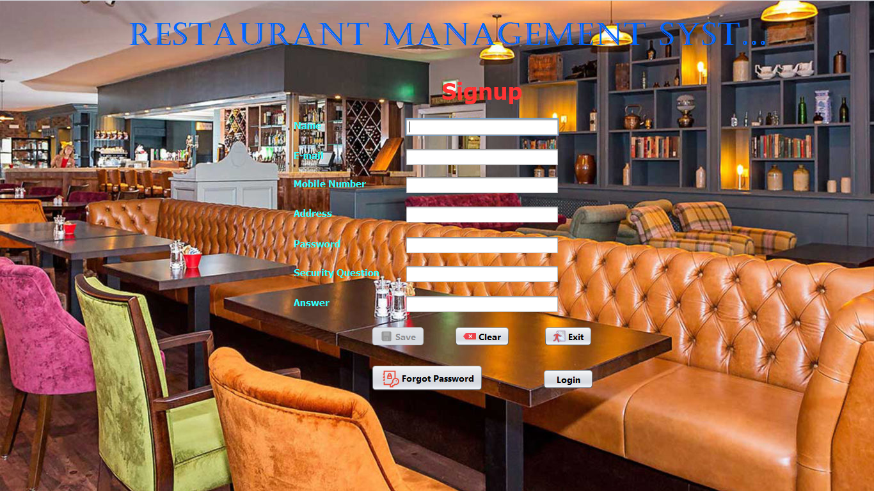

Figure no.:-2

**Signup :-**

/*

* Click nbfs://nbhost/SystemFileSystem/Templates/Licenses/license-default.txt to change this license

* Click nbfs://nbhost/SystemFileSystem/Templates/GUIForms/JFrame.java to edit this template

*/

package cafe.management.system;

import javax.swing.JOptionPane;

import model.User;

import dao.UserDao;

/**

*

* @author Amarjeet

*/

public class signup extends javax.swing.JFrame {

public String emailPattern = "^[a-zA-Z0-9]+[@]+[a-zA-Z0-9]+[.]+[a-zA-Z0-9]+$";

public String mobileNumberPattern = "^[0-9]*$";

/**

* Creates new form signup

*/

public signup() {

initComponents();

btnSave.setEnabled(false);

}

public void Clear() {

txtName.setText("");

txtEmail.setText("");

txtMobileNumber.setText("");

txtAddress.setText("");

txtSecurity.setText("");

txtAnswer.setText("");

txtPassword.setText("");

btnSave.setEnabled(false);

}

public void validateFields() {

String name = txtName.getText();

String email = txtEmail.getText();

String mobileNumber = txtMobileNumber.getText();

String address = txtAddress.getText();

String password = txtPassword.getText();

String securityQuestion = txtSecurity.getText();

String answer = txtAnswer.getText();

if (!name.equals("") && email.matches(emailPattern) && mobileNumber.matches(mobileNumberPattern) && mobileNumber.length() == 12 && !address.equals("") && !password.equals("") && !securityQuestion.equals("") && !answer.equals("")) {

btnSave.setEnabled(true);

} else {

btnSave.setEnabled(false);

}

}

/**

* This method is called from within the constructor to initialize the form.

* WARNING: Do NOT modify this code. The content of this method is always

* regenerated by the Form Editor.

*/

@SuppressWarnings("unchecked")

// <editor-fold defaultstate="collapsed" desc="Generated Code">

private void initComponents() {

jLabel1 = new javax.swing.JLabel();

jLabel2 = new javax.swing.JLabel();

jLabel3 = new javax.swing.JLabel();

jLabel4 = new javax.swing.JLabel();

jLabel5 = new javax.swing.JLabel();

jLabel6 = new javax.swing.JLabel();

jLabel7 = new javax.swing.JLabel();

jLabel8 = new javax.swing.JLabel();

txtName = new javax.swing.JTextField();

txtEmail = new javax.swing.JTextField();

txtMobileNumber = new javax.swing.JTextField();

txtAddress = new javax.swing.JTextField();

txtSecurity = new javax.swing.JTextField();

txtAnswer = new javax.swing.JTextField();

txtPassword = new javax.swing.JPasswordField();

btnSave = new javax.swing.JButton();

btnClear = new javax.swing.JButton();

btnExit = new javax.swing.JButton();

jButton4 = new javax.swing.JButton();

jButton5 = new javax.swing.JButton();

jLabel10 = new javax.swing.JLabel();

jLabel9 = new javax.swing.JLabel();

setDefaultCloseOperation(javax.swing.WindowConstants.EXIT_ON_CLOSE);

setUndecorated(true);

getContentPane().setLayout(new org.netbeans.lib.awtextra.AbsoluteLayout());

jLabel1.setFont(new java.awt.Font("Tahoma", 1, 36)); // NOI18N

jLabel1.setForeground(new java.awt.Color(255, 51, 51));

jLabel1.setText("Signup");

getContentPane().add(jLabel1, new org.netbeans.lib.awtextra.AbsoluteConstraints(690, 120, -1, -1));

jLabel2.setFont(new java.awt.Font("Tahoma", 1, 15)); // NOI18N

jLabel2.setForeground(new java.awt.Color(51, 255, 255));

jLabel2.setText("Name");

getContentPane().add(jLabel2, new org.netbeans.lib.awtextra.AbsoluteConstraints(459, 187, -1, -1));

jLabel3.setFont(new java.awt.Font("Tahoma", 1, 15)); // NOI18N

jLabel3.setForeground(new java.awt.Color(51, 255, 255));

jLabel3.setText("E-mail");

getContentPane().add(jLabel3, new org.netbeans.lib.awtextra.AbsoluteConstraints(459, 234, -1, -1));

jLabel4.setFont(new java.awt.Font("Tahoma", 1, 15)); // NOI18N

jLabel4.setForeground(new java.awt.Color(51, 255, 255));

jLabel4.setText("Mobile Number");

getContentPane().add(jLabel4, new org.netbeans.lib.awtextra.AbsoluteConstraints(459, 278, -1, -1));

jLabel5.setFont(new java.awt.Font("Tahoma", 1, 15)); // NOI18N

jLabel5.setForeground(new java.awt.Color(51, 255, 255));

jLabel5.setText("Address");

getContentPane().add(jLabel5, new org.netbeans.lib.awtextra.AbsoluteConstraints(459, 324, -1, -1));

jLabel6.setFont(new java.awt.Font("Tahoma", 1, 15)); // NOI18N

jLabel6.setForeground(new java.awt.Color(51, 255, 255));

jLabel6.setText("Password");

getContentPane().add(jLabel6, new org.netbeans.lib.awtextra.AbsoluteConstraints(459, 372, -1, -1));

jLabel7.setFont(new java.awt.Font("Tahoma", 1, 15)); // NOI18N

jLabel7.setForeground(new java.awt.Color(51, 255, 255));

jLabel7.setText("Security Question");

getContentPane().add(jLabel7, new org.netbeans.lib.awtextra.AbsoluteConstraints(459, 417, -1, -1));

jLabel8.setFont(new java.awt.Font("Tahoma", 1, 15)); // NOI18N

jLabel8.setForeground(new java.awt.Color(51, 255, 255));

jLabel8.setText("Answer");

getContentPane().add(jLabel8, new org.netbeans.lib.awtextra.AbsoluteConstraints(459, 464, -1, -1));

txtName.setFont(new java.awt.Font("Tahoma", 1, 14)); // NOI18N

txtName.addKeyListener(new java.awt.event.KeyAdapter() {

public void keyReleased(java.awt.event.KeyEvent evt) {

txtNameKeyReleased(evt);

}

});

getContentPane().add(txtName, new org.netbeans.lib.awtextra.AbsoluteConstraints(633, 184, 241, -1));

txtEmail.setFont(new java.awt.Font("Tahoma", 1, 14)); // NOI18N

txtEmail.addKeyListener(new java.awt.event.KeyAdapter() {

public void keyReleased(java.awt.event.KeyEvent evt) {

txtEmailKeyReleased(evt);

}

});

getContentPane().add(txtEmail, new org.netbeans.lib.awtextra.AbsoluteConstraints(633, 231, 241, -1));

txtMobileNumber.setFont(new java.awt.Font("Tahoma", 1, 14)); // NOI18N

txtMobileNumber.addKeyListener(new java.awt.event.KeyAdapter() {

public void keyReleased(java.awt.event.KeyEvent evt) {

txtMobileNumberKeyReleased(evt);

}

});

getContentPane().add(txtMobileNumber, new org.netbeans.lib.awtextra.AbsoluteConstraints(633, 275, 241, -1));

txtAddress.setFont(new java.awt.Font("Tahoma", 1, 14)); // NOI18N

txtAddress.addKeyListener(new java.awt.event.KeyAdapter() {

public void keyReleased(java.awt.event.KeyEvent evt) {

txtAddressKeyReleased(evt);

}

});

getContentPane().add(txtAddress, new org.netbeans.lib.awtextra.AbsoluteConstraints(633, 321, 241, -1));

txtSecurity.setFont(new java.awt.Font("Tahoma", 1, 14)); // NOI18N

txtSecurity.addKeyListener(new java.awt.event.KeyAdapter() {

public void keyReleased(java.awt.event.KeyEvent evt) {

txtSecurityKeyReleased(evt);

}

});

getContentPane().add(txtSecurity, new org.netbeans.lib.awtextra.AbsoluteConstraints(633, 414, 241, -1));

txtAnswer.setFont(new java.awt.Font("Tahoma", 1, 14)); // NOI18N

txtAnswer.addKeyListener(new java.awt.event.KeyAdapter() {

public void keyReleased(java.awt.event.KeyEvent evt) {

txtAnswerKeyReleased(evt);

}

});

getContentPane().add(txtAnswer, new org.netbeans.lib.awtextra.AbsoluteConstraints(633, 461, 241, -1));

txtPassword.setFont(new java.awt.Font("Tahoma", 1, 14)); // NOI18N

txtPassword.addKeyListener(new java.awt.event.KeyAdapter() {

public void keyReleased(java.awt.event.KeyEvent evt) {

txtPasswordKeyReleased(evt);

}

});

getContentPane().add(txtPassword, new org.netbeans.lib.awtextra.AbsoluteConstraints(633, 369, 241, -1));

btnSave.setFont(new java.awt.Font("Segoe UI", 1, 14)); // NOI18N

btnSave.setIcon(new javax.swing.ImageIcon(getClass().getResource("/image/save.png"))); // NOI18N

btnSave.setText("Save");

btnSave.addActionListener(new java.awt.event.ActionListener() {

public void actionPerformed(java.awt.event.ActionEvent evt) {

btnSaveActionPerformed(evt);

}

});

getContentPane().add(btnSave, new org.netbeans.lib.awtextra.AbsoluteConstraints(580, 510, -1, -1));

btnClear.setFont(new java.awt.Font("Segoe UI", 1, 14)); // NOI18N

btnClear.setIcon(new javax.swing.ImageIcon(getClass().getResource("/image/clear.png"))); // NOI18N

btnClear.setText("Clear");

btnClear.addActionListener(new java.awt.event.ActionListener() {

public void actionPerformed(java.awt.event.ActionEvent evt) {

btnClearActionPerformed(evt);

}

});

getContentPane().add(btnClear, new org.netbeans.lib.awtextra.AbsoluteConstraints(710, 510, -1, -1));

btnExit.setFont(new java.awt.Font("Segoe UI", 1, 14)); // NOI18N

btnExit.setIcon(new javax.swing.ImageIcon(getClass().getResource("/image/exit small.png"))); // NOI18N

btnExit.setText("Exit");

btnExit.addActionListener(new java.awt.event.ActionListener() {

public void actionPerformed(java.awt.event.ActionEvent evt) {

btnExitActionPerformed(evt);

}

});

getContentPane().add(btnExit, new org.netbeans.lib.awtextra.AbsoluteConstraints(850, 510, -1, -1));

jButton4.setFont(new java.awt.Font("Segoe UI", 1, 14)); // NOI18N

jButton4.setIcon(new javax.swing.ImageIcon(getClass().getResource("/image/change Password.png"))); // NOI18N

jButton4.setText("Forgot Password");

jButton4.addActionListener(new java.awt.event.ActionListener() {

public void actionPerformed(java.awt.event.ActionEvent evt) {

jButton4ActionPerformed(evt);

}

});

getContentPane().add(jButton4, new org.netbeans.lib.awtextra.AbsoluteConstraints(580, 570, -1, -1));

jButton5.setFont(new java.awt.Font("Segoe UI", 1, 14)); // NOI18N

jButton5.setText("Login");

jButton5.addActionListener(new java.awt.event.ActionListener() {

public void actionPerformed(java.awt.event.ActionEvent evt) {

jButton5ActionPerformed(evt);

}

});

getContentPane().add(jButton5, new org.netbeans.lib.awtextra.AbsoluteConstraints(848, 577, 80, -1));

jLabel10.setFont(new java.awt.Font("Castellar", 1, 48)); // NOI18N

jLabel10.setForeground(new java.awt.Color(0, 102, 255));

jLabel10.setText("Restaurant Management System");

getContentPane().add(jLabel10, new org.netbeans.lib.awtextra.AbsoluteConstraints(200, 30, 1000, 50));

jLabel9.setIcon(new javax.swing.ImageIcon(getClass().getResource("/image/backHomePage.jpeg"))); // NOI18N

getContentPane().add(jLabel9, new org.netbeans.lib.awtextra.AbsoluteConstraints(0, 0, 1370, 770));

pack();

}// </editor-fold>

private void btnExitActionPerformed(java.awt.event.ActionEvent evt) {

// TODO add your handling code here:

int a = JOptionPane.showConfirmDialog(null, "Do you really want to close Application ", "Select", JOptionPane.YES_NO_OPTION);

if (a == 0) {

System.exit(0);

}

}

private void btnSaveActionPerformed(java.awt.event.ActionEvent evt) {

// TODO add your handling code here:

User user = new User();

user.setName(txtName.getText());

user.setEmail(txtEmail.getText());

user.setMobileNumber(txtMobileNumber.getText());

user.setAddress(txtAddress.getText());

user.setPassword(txtPassword.getText());

user.setSecurity(txtSecurity.getText());

user.setAnswer(txtAnswer.getText());

UserDao.save(user);

Clear();

}

private void btnClearActionPerformed(java.awt.event.ActionEvent evt) {

// TODO add your handling code here:

Clear();

}

private void txtNameKeyReleased(java.awt.event.KeyEvent evt) {

// TODO add your handling code here:

validateFields();

}

private void txtEmailKeyReleased(java.awt.event.KeyEvent evt) {

// TODO add your handling code here:

validateFields();

}

private void txtMobileNumberKeyReleased(java.awt.event.KeyEvent evt) {

// TODO add your handling code here:

validateFields();

}

private void txtAddressKeyReleased(java.awt.event.KeyEvent evt) {

// TODO add your handling code here:

validateFields();

}

private void txtPasswordKeyReleased(java.awt.event.KeyEvent evt) {

// TODO add your handling code here:

validateFields();

}

private void txtSecurityKeyReleased(java.awt.event.KeyEvent evt) {

// TODO add your handling code here:

validateFields();

}

private void txtAnswerKeyReleased(java.awt.event.KeyEvent evt) {

// TODO add your handling code here:

validateFields();

}

private void jButton5ActionPerformed(java.awt.event.ActionEvent evt) {

// TODO add your handling code here:

setVisible(false);

new Login().setVisible(true);

}

private void jButton4ActionPerformed(java.awt.event.ActionEvent evt) {

// TODO add your handling code here:

setVisible(false);

new ForgotPassword().setVisible(true);

}

/**

* @param args the command line arguments

*/

public static void main(String args[]) {

/* Set the Nimbus look and feel */

//<editor-fold defaultstate="collapsed" desc=" Look and feel setting code (optional) ">

/* If Nimbus (introduced in Java SE 6) is not available, stay with the default look and feel.

* For details see http://download.oracle.com/javase/tutorial/uiswing/lookandfeel/plaf.html

*/

try {

for (javax.swing.UIManager.LookAndFeelInfo info : javax.swing.UIManager.getInstalledLookAndFeels()) {

if ("Nimbus".equals(info.getName())) {

javax.swing.UIManager.setLookAndFeel(info.getClassName());

break;

}

}

} catch (ClassNotFoundException ex) {

java.util.logging.Logger.getLogger(signup.class.getName()).log(java.util.logging.Level.SEVERE, null, ex);

} catch (InstantiationException ex) {

java.util.logging.Logger.getLogger(signup.class.getName()).log(java.util.logging.Level.SEVERE, null, ex);

} catch (IllegalAccessException ex) {

java.util.logging.Logger.getLogger(signup.class.getName()).log(java.util.logging.Level.SEVERE, null, ex);

} catch (javax.swing.UnsupportedLookAndFeelException ex) {

java.util.logging.Logger.getLogger(signup.class.getName()).log(java.util.logging.Level.SEVERE, null, ex);

}

//</editor-fold>

/* Create and display the form */

java.awt.EventQueue.invokeLater(new Runnable() {

public void run() {

new signup().setVisible(true);

}

});

}

// Variables declaration - do not modify

private javax.swing.JButton btnClear;

private javax.swing.JButton btnExit;

private javax.swing.JButton btnSave;

private javax.swing.JButton jButton4;

private javax.swing.JButton jButton5;

private javax.swing.JLabel jLabel1;

private javax.swing.JLabel jLabel10;

private javax.swing.JLabel jLabel2;

private javax.swing.JLabel jLabel3;

private javax.swing.JLabel jLabel4;

private javax.swing.JLabel jLabel5;

private javax.swing.JLabel jLabel6;

private javax.swing.JLabel jLabel7;

private javax.swing.JLabel jLabel8;

private javax.swing.JLabel jLabel9;

private javax.swing.JTextField txtAddress;

private javax.swing.JTextField txtAnswer;

private javax.swing.JTextField txtEmail;

private javax.swing.JTextField txtMobileNumber;

private javax.swing.JTextField txtName;

private javax.swing.JPasswordField txtPassword;

private javax.swing.JTextField txtSecurity;

// End of variables declaration

}

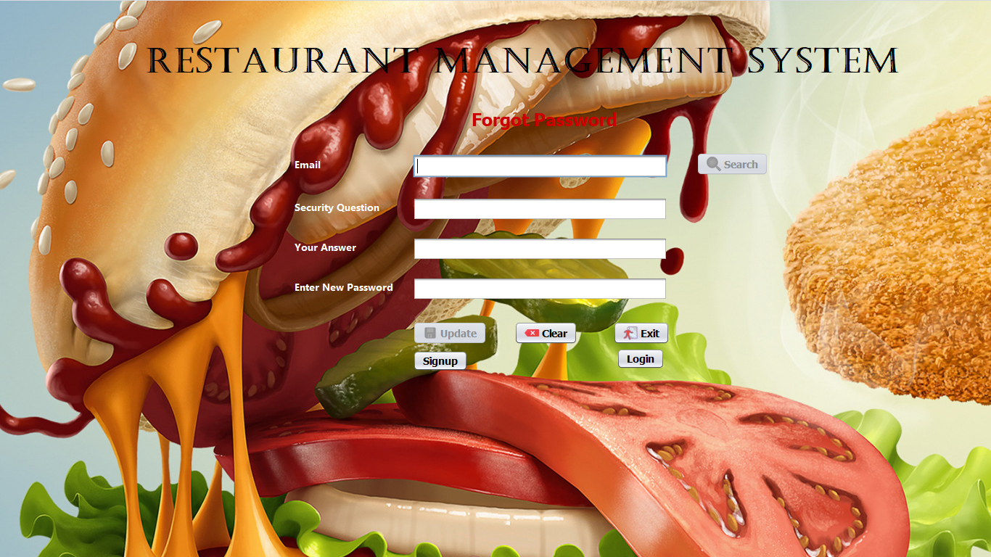

Figure no.:-3

**Forgot Password:-**

package cafe.management.system;

import javax.swing.JOptionPane;

import model.User;

import dao.UserDao;

/**

*

* @author Amarjeet

*/

public class ForgotPassword extends javax.swing.JFrame {

private String dbAnswer=null;

private String email=null;

private String emailPattern="^[a-zA-Z0-9]+[@]+[a-zA-Z0-9]+[.]+[a-zA-Z0-9]+$";

/**

* Creates new form ForgotPassword

*/

public ForgotPassword() {

initComponents();

btnUpdate.setEnabled(false);

btnSearch.setEnabled(false);

txtSecurityQuestion.setEditable(false);

}

public void clear()

{

btnUpdate.setEnabled(false);

btnSearch.setEnabled(false);

txtEmail.setEditable(true);

txtEmail.setText("");

txtSecurityQuestion.setText("");

txtAnswer.setText("");

txtNewPassword.setText("");

}

public void validateEmail()

{

email = txtEmail.getText();

if(email.matches(emailPattern))

btnSearch.setEnabled(true);

else

btnSearch.setEnabled(false);

}

public void validateFields()

{

String password=txtNewPassword.getText();

String answer=txtAnswer.getText();

String securityQuestion=txtSecurityQuestion.getText();

if(!password.equals("")&& !answer.equals("")&& !securityQuestion.equals(""))

btnUpdate.setEnabled(true);

else

btnUpdate.setEnabled(false);

}

/**

* This method is called from within the constructor to initialize the form.

* WARNING: Do NOT modify this code. The content of this method is always

* regenerated by the Form Editor.

*/

@SuppressWarnings("unchecked")

// <editor-fold defaultstate="collapsed" desc="Generated Code">

private void initComponents() {

jLabel1 = new javax.swing.JLabel();

jLabel2 = new javax.swing.JLabel();

jLabel3 = new javax.swing.JLabel();

jLabel4 = new javax.swing.JLabel();

jLabel5 = new javax.swing.JLabel();

txtEmail = new javax.swing.JTextField();

txtSecurityQuestion = new javax.swing.JTextField();

txtAnswer = new javax.swing.JTextField();

txtNewPassword = new javax.swing.JPasswordField();

btnUpdate = new javax.swing.JButton();

btnClear = new javax.swing.JButton();

jButton3 = new javax.swing.JButton();

jButton4 = new javax.swing.JButton();

jButton5 = new javax.swing.JButton();

btnSearch = new javax.swing.JButton();

jLabel7 = new javax.swing.JLabel();

jLabel6 = new javax.swing.JLabel();

setDefaultCloseOperation(javax.swing.WindowConstants.EXIT_ON_CLOSE);

setUndecorated(true);

getContentPane().setLayout(new org.netbeans.lib.awtextra.AbsoluteLayout());

jLabel1.setFont(new java.awt.Font("Tahoma", 1, 24)); // NOI18N

jLabel1.setForeground(new java.awt.Color(204, 0, 0));

jLabel1.setText("Forgot Password");

getContentPane().add(jLabel1, new org.netbeans.lib.awtextra.AbsoluteConstraints(650, 150, -1, -1));

jLabel2.setFont(new java.awt.Font("Segoe UI", 1, 14)); // NOI18N

jLabel2.setForeground(new java.awt.Color(255, 255, 255));

jLabel2.setText("Email");

getContentPane().add(jLabel2, new org.netbeans.lib.awtextra.AbsoluteConstraints(406, 216, -1, -1));

jLabel3.setFont(new java.awt.Font("Segoe UI", 1, 14)); // NOI18N

jLabel3.setForeground(new java.awt.Color(255, 255, 255));

jLabel3.setText("Security Question");

getContentPane().add(jLabel3, new org.netbeans.lib.awtextra.AbsoluteConstraints(406, 275, -1, -1));

jLabel4.setFont(new java.awt.Font("Segoe UI", 1, 14)); // NOI18N

jLabel4.setForeground(new java.awt.Color(255, 255, 255));

jLabel4.setText("Your Answer");

getContentPane().add(jLabel4, new org.netbeans.lib.awtextra.AbsoluteConstraints(406, 330, -1, -1));

jLabel5.setFont(new java.awt.Font("Segoe UI", 1, 14)); // NOI18N

jLabel5.setForeground(new java.awt.Color(255, 255, 255));

jLabel5.setText("Enter New Password");

getContentPane().add(jLabel5, new org.netbeans.lib.awtextra.AbsoluteConstraints(406, 385, -1, -1));

txtEmail.setFont(new java.awt.Font("Segoe UI", 1, 14)); // NOI18N

txtEmail.addKeyListener(new java.awt.event.KeyAdapter() {

public void keyReleased(java.awt.event.KeyEvent evt) {

txtEmailKeyReleased(evt);

}

});

getContentPane().add(txtEmail, new org.netbeans.lib.awtextra.AbsoluteConstraints(569, 213, 351, -1));

txtSecurityQuestion.setFont(new java.awt.Font("Segoe UI", 1, 14)); // NOI18N

txtSecurityQuestion.addKeyListener(new java.awt.event.KeyAdapter() {

public void keyReleased(java.awt.event.KeyEvent evt) {

txtSecurityQuestionKeyReleased(evt);

}

});

getContentPane().add(txtSecurityQuestion, new org.netbeans.lib.awtextra.AbsoluteConstraints(569, 272, 351, -1));

txtAnswer.setFont(new java.awt.Font("Segoe UI", 1, 14)); // NOI18N

txtAnswer.addKeyListener(new java.awt.event.KeyAdapter() {

public void keyReleased(java.awt.event.KeyEvent evt) {

txtAnswerKeyReleased(evt);

}

});

getContentPane().add(txtAnswer, new org.netbeans.lib.awtextra.AbsoluteConstraints(569, 327, 351, -1));

txtNewPassword.setFont(new java.awt.Font("Segoe UI", 1, 14)); // NOI18N

txtNewPassword.addKeyListener(new java.awt.event.KeyAdapter() {

public void keyReleased(java.awt.event.KeyEvent evt) {

txtNewPasswordKeyReleased(evt);

}

});

getContentPane().add(txtNewPassword, new org.netbeans.lib.awtextra.AbsoluteConstraints(569, 382, 351, -1));

btnUpdate.setFont(new java.awt.Font("Tahoma", 1, 14)); // NOI18N

btnUpdate.setIcon(new javax.swing.ImageIcon(getClass().getResource("/image/save.png"))); // NOI18N

btnUpdate.setText("Update");

btnUpdate.addActionListener(new java.awt.event.ActionListener() {

public void actionPerformed(java.awt.event.ActionEvent evt) {

btnUpdateActionPerformed(evt);

}

});

getContentPane().add(btnUpdate, new org.netbeans.lib.awtextra.AbsoluteConstraints(569, 443, -1, -1));

btnClear.setFont(new java.awt.Font("Tahoma", 1, 14)); // NOI18N

btnClear.setIcon(new javax.swing.ImageIcon(getClass().getResource("/image/clear.png"))); // NOI18N

btnClear.setText("Clear");

btnClear.addActionListener(new java.awt.event.ActionListener() {

public void actionPerformed(java.awt.event.ActionEvent evt) {

btnClearActionPerformed(evt);

}

});

getContentPane().add(btnClear, new org.netbeans.lib.awtextra.AbsoluteConstraints(709, 443, -1, -1));

jButton3.setFont(new java.awt.Font("Tahoma", 1, 14)); // NOI18N

jButton3.setIcon(new javax.swing.ImageIcon(getClass().getResource("/image/exit small.png"))); // NOI18N

jButton3.setText("Exit");

jButton3.addActionListener(new java.awt.event.ActionListener() {

public void actionPerformed(java.awt.event.ActionEvent evt) {

jButton3ActionPerformed(evt);

}

});

getContentPane().add(jButton3, new org.netbeans.lib.awtextra.AbsoluteConstraints(845, 443, -1, -1));

jButton4.setFont(new java.awt.Font("Tahoma", 1, 14)); // NOI18N

jButton4.setText("Signup");

jButton4.addActionListener(new java.awt.event.ActionListener() {

public void actionPerformed(java.awt.event.ActionEvent evt) {

jButton4ActionPerformed(evt);

}

});

getContentPane().add(jButton4, new org.netbeans.lib.awtextra.AbsoluteConstraints(569, 483, -1, -1));

jButton5.setFont(new java.awt.Font("Tahoma", 1, 14)); // NOI18N

jButton5.setText("Login");

jButton5.addActionListener(new java.awt.event.ActionListener() {

public void actionPerformed(java.awt.event.ActionEvent evt) {

jButton5ActionPerformed(evt);

}

});

getContentPane().add(jButton5, new org.netbeans.lib.awtextra.AbsoluteConstraints(850, 480, -1, -1));

btnSearch.setFont(new java.awt.Font("Tahoma", 1, 14)); // NOI18N

btnSearch.setIcon(new javax.swing.ImageIcon(getClass().getResource("/image/search.png"))); // NOI18N

btnSearch.setText("Search");

btnSearch.addActionListener(new java.awt.event.ActionListener() {

public void actionPerformed(java.awt.event.ActionEvent evt) {

btnSearchActionPerformed(evt);

}

});

getContentPane().add(btnSearch, new org.netbeans.lib.awtextra.AbsoluteConstraints(960, 210, -1, -1));

jLabel7.setFont(new java.awt.Font("Castellar", 1, 48)); // NOI18N

jLabel7.setText("Restaurant Management System");

getContentPane().add(jLabel7, new org.netbeans.lib.awtextra.AbsoluteConstraints(200, 60, -1, 50));

jLabel6.setIcon(new javax.swing.ImageIcon(getClass().getResource("/image/foodForgot.jpg"))); // NOI18N

getContentPane().add(jLabel6, new org.netbeans.lib.awtextra.AbsoluteConstraints(0, 0, 1370, 770));

pack();

}// </editor-fold>

private void txtEmailKeyReleased(java.awt.event.KeyEvent evt) {

// TODO add your handling code here:

validateEmail();

}

private void txtSecurityQuestionKeyReleased(java.awt.event.KeyEvent evt) {

// TODO add your handling code here:

validateFields();

}

private void txtAnswerKeyReleased(java.awt.event.KeyEvent evt) {

// TODO add your handling code here:

validateFields();

}

private void txtNewPasswordKeyReleased(java.awt.event.KeyEvent evt) {

// TODO add your handling code here:

validateFields();

}

private void jButton3ActionPerformed(java.awt.event.ActionEvent evt) {

// TODO add your handling code here:

int a= JOptionPane.showConfirmDialog(null, "Do you really want to closed Application","Select",JOptionPane.YES_NO_OPTION);

if(a==0)

{

System.exit(0);

}

}

private void btnClearActionPerformed(java.awt.event.ActionEvent evt) {

// TODO add your handling code here:

clear();

}

private void btnUpdateActionPerformed(java.awt.event.ActionEvent evt) {

// TODO add your handling code here:

String answer=txtAnswer.getText();

String newPassword=txtNewPassword.getText();

if(answer.equals(dbAnswer))

{

UserDao.update(email, newPassword);

clear();

}

else

{

JOptionPane.showMessageDialog(null, "<html><b style=\"color:red\">Incorrect Answer</b></html>","Message",JOptionPane.ERROR_MESSAGE);

}

}

private void btnSearchActionPerformed(java.awt.event.ActionEvent evt) {

// TODO add your handling code here:

email=txtEmail.getText();

User user=null;

user=UserDao.getSecurityQuestion(email);

if(user==null)

{

JOptionPane.showMessageDialog(null, "<html><b style=\"color:red\">Incorrect Email</b></html>","Message",JOptionPane.ERROR_MESSAGE);

}

else

{

btnSearch.setEnabled(false);

txtEmail.setEditable(false);

dbAnswer=user.getAnswer();

txtSecurityQuestion.setText(user.getSecurity());

validateFields();

}

}

private void jButton4ActionPerformed(java.awt.event.ActionEvent evt) {

// TODO add your handling code here:

setVisible(false);

new signup().setVisible(true);

}

private void jButton5ActionPerformed(java.awt.event.ActionEvent evt) {

// TODO add your handling code here:

setVisible(false);

new Login().setVisible(true);

}

/**

* @param args the command line arguments

*/

public static void main(String args[]) {

/* Set the Nimbus look and feel */

//<editor-fold defaultstate="collapsed" desc=" Look and feel setting code (optional) ">

/* If Nimbus (introduced in Java SE 6) is not available, stay with the default look and feel.

* For details see http://download.oracle.com/javase/tutorial/uiswing/lookandfeel/plaf.html

*/

try {

for (javax.swing.UIManager.LookAndFeelInfo info : javax.swing.UIManager.getInstalledLookAndFeels()) {

if ("Nimbus".equals(info.getName())) {

javax.swing.UIManager.setLookAndFeel(info.getClassName());

break;

}

}

} catch (ClassNotFoundException ex) {

java.util.logging.Logger.getLogger(ForgotPassword.class.getName()).log(java.util.logging.Level.SEVERE, null, ex);

} catch (InstantiationException ex) {

java.util.logging.Logger.getLogger(ForgotPassword.class.getName()).log(java.util.logging.Level.SEVERE, null, ex);

} catch (IllegalAccessException ex) {

java.util.logging.Logger.getLogger(ForgotPassword.class.getName()).log(java.util.logging.Level.SEVERE, null, ex);

} catch (javax.swing.UnsupportedLookAndFeelException ex) {

java.util.logging.Logger.getLogger(ForgotPassword.class.getName()).log(java.util.logging.Level.SEVERE, null, ex);

}

//</editor-fold>

/* Create and display the form */

java.awt.EventQueue.invokeLater(new Runnable() {

public void run() {

new ForgotPassword().setVisible(true);

}

});

}

// Variables declaration - do not modify

private javax.swing.JButton btnClear;

private javax.swing.JButton btnSearch;

private javax.swing.JButton btnUpdate;

private javax.swing.JButton jButton3;

private javax.swing.JButton jButton4;

private javax.swing.JButton jButton5;

private javax.swing.JLabel jLabel1;

private javax.swing.JLabel jLabel2;

private javax.swing.JLabel jLabel3;

private javax.swing.JLabel jLabel4;

private javax.swing.JLabel jLabel5;

private javax.swing.JLabel jLabel6;

private javax.swing.JLabel jLabel7;

private javax.swing.JTextField txtAnswer;

private javax.swing.JTextField txtEmail;

private javax.swing.JPasswordField txtNewPassword;

private javax.swing.JTextField txtSecurityQuestion;

// End of variables declaration

}

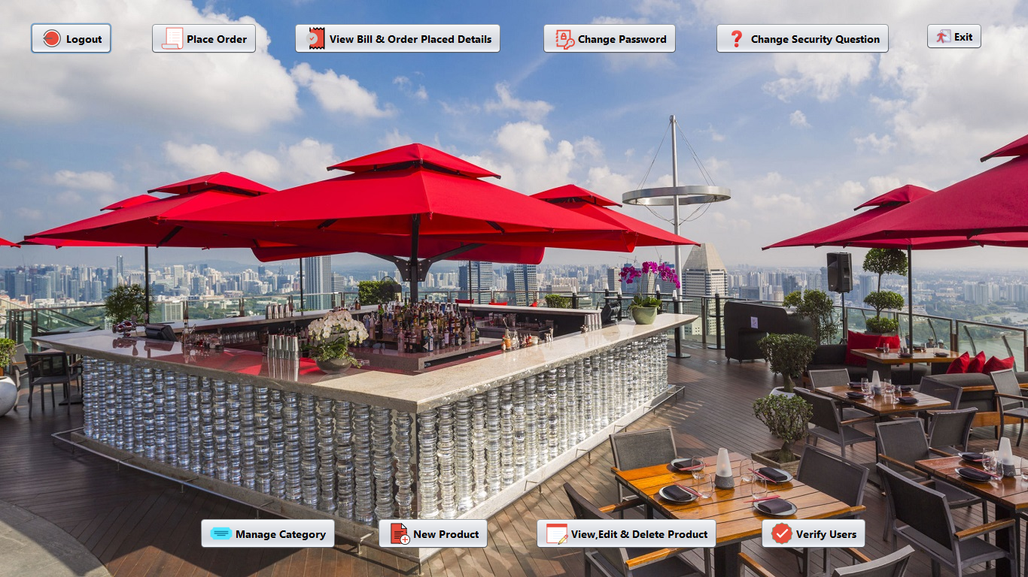

Figure No.:-3

**Home Page:-**

/*

* Click nbfs://nbhost/SystemFileSystem/Templates/Licenses/license-default.txt to change this license

* Click nbfs://nbhost/SystemFileSystem/Templates/GUIForms/JFrame.java to edit this template

*/

package cafe.management.system;

import javax.swing.JOptionPane;

/**

*

* @author Amarjeet

*/

public class Home extends javax.swing.JFrame {

public String email;

/**

* Creates new form Home

*/

public Home() {

initComponents();

}

public Home(String userEmail) {

initComponents();

email=userEmail;

if(!email.equals("admin@gmail.com"))

{

btnCategory.setVisible(false);

btnNewProduct.setVisible(false);

btnViewEditDeleteProduct.setVisible(false);

btnVerifyUsers.setVisible(false);

}

}

/**

* This method is called from within the constructor to initialize the form.

* WARNING: Do NOT modify this code. The content of this method is always

* regenerated by the Form Editor.

*/

@SuppressWarnings("unchecked")

// <editor-fold defaultstate="collapsed" desc="Generated Code">

private void initComponents() {

jButton1 = new javax.swing.JButton();

jButton2 = new javax.swing.JButton();

jButton3 = new javax.swing.JButton();

jButton4 = new javax.swing.JButton();

jButton5 = new javax.swing.JButton();

jButton6 = new javax.swing.JButton();

btnCategory = new javax.swing.JButton();

btnNewProduct = new javax.swing.JButton();

btnViewEditDeleteProduct = new javax.swing.JButton();

btnVerifyUsers = new javax.swing.JButton();

jLabel2 = new javax.swing.JLabel();

setDefaultCloseOperation(javax.swing.WindowConstants.EXIT_ON_CLOSE);

setUndecorated(true);

getContentPane().setLayout(new org.netbeans.lib.awtextra.AbsoluteLayout());

jButton1.setFont(new java.awt.Font("Segoe UI", 1, 14)); // NOI18N

jButton1.setIcon(new javax.swing.ImageIcon(getClass().getResource("/image/logout.png"))); // NOI18N

jButton1.setText("Logout");

jButton1.addActionListener(new java.awt.event.ActionListener() {

public void actionPerformed(java.awt.event.ActionEvent evt) {

jButton1ActionPerformed(evt);

}

});

getContentPane().add(jButton1, new org.netbeans.lib.awtextra.AbsoluteConstraints(40, 30, -1, -1));

jButton2.setFont(new java.awt.Font("Segoe UI", 1, 14)); // NOI18N

jButton2.setIcon(new javax.swing.ImageIcon(getClass().getResource("/image/place order.png"))); // NOI18N

jButton2.setText("Place Order");

jButton2.addActionListener(new java.awt.event.ActionListener() {

public void actionPerformed(java.awt.event.ActionEvent evt) {

jButton2ActionPerformed(evt);

}

});

getContentPane().add(jButton2, new org.netbeans.lib.awtextra.AbsoluteConstraints(200, 30, -1, -1));

jButton3.setFont(new java.awt.Font("Segoe UI", 1, 14)); // NOI18N

jButton3.setIcon(new javax.swing.ImageIcon(getClass().getResource("/image/View Bills & Order Placed Details.png"))); // NOI18N

jButton3.setText("View Bill & Order Placed Details");

jButton3.addActionListener(new java.awt.event.ActionListener() {

public void actionPerformed(java.awt.event.ActionEvent evt) {

jButton3ActionPerformed(evt);

}

});

getContentPane().add(jButton3, new org.netbeans.lib.awtextra.AbsoluteConstraints(390, 30, -1, -1));

jButton4.setFont(new java.awt.Font("Segoe UI", 1, 14)); // NOI18N

jButton4.setIcon(new javax.swing.ImageIcon(getClass().getResource("/image/change Password.png"))); // NOI18N

jButton4.setText("Change Password");

jButton4.addActionListener(new java.awt.event.ActionListener() {

public void actionPerformed(java.awt.event.ActionEvent evt) {

jButton4ActionPerformed(evt);

}

});

getContentPane().add(jButton4, new org.netbeans.lib.awtextra.AbsoluteConstraints(720, 30, -1, -1));

jButton5.setFont(new java.awt.Font("Segoe UI", 1, 14)); // NOI18N

jButton5.setIcon(new javax.swing.ImageIcon(getClass().getResource("/image/change Security Question.png"))); // NOI18N

jButton5.setText("Change Security Question");

jButton5.addActionListener(new java.awt.event.ActionListener() {

public void actionPerformed(java.awt.event.ActionEvent evt) {

jButton5ActionPerformed(evt);

}

});

getContentPane().add(jButton5, new org.netbeans.lib.awtextra.AbsoluteConstraints(950, 30, -1, -1));

jButton6.setFont(new java.awt.Font("Segoe UI", 1, 14)); // NOI18N

jButton6.setIcon(new javax.swing.ImageIcon(getClass().getResource("/image/exit small.png"))); // NOI18N

jButton6.setText("Exit");

jButton6.addActionListener(new java.awt.event.ActionListener() {

public void actionPerformed(java.awt.event.ActionEvent evt) {

jButton6ActionPerformed(evt);

}

});

getContentPane().add(jButton6, new org.netbeans.lib.awtextra.AbsoluteConstraints(1230, 30, -1, 36));

btnCategory.setFont(new java.awt.Font("Segoe UI", 1, 14)); // NOI18N

btnCategory.setIcon(new javax.swing.ImageIcon(getClass().getResource("/image/category.png"))); // NOI18N

btnCategory.setText("Manage Category");

btnCategory.addActionListener(new java.awt.event.ActionListener() {

public void actionPerformed(java.awt.event.ActionEvent evt) {

btnCategoryActionPerformed(evt);

}

});

getContentPane().add(btnCategory, new org.netbeans.lib.awtextra.AbsoluteConstraints(265, 689, -1, -1));

btnNewProduct.setFont(new java.awt.Font("Segoe UI", 1, 14)); // NOI18N

btnNewProduct.setIcon(new javax.swing.ImageIcon(getClass().getResource("/image/new product.png"))); // NOI18N

btnNewProduct.setText("New Product");

btnNewProduct.addActionListener(new java.awt.event.ActionListener() {

public void actionPerformed(java.awt.event.ActionEvent evt) {

btnNewProductActionPerformed(evt);

}

});

getContentPane().add(btnNewProduct, new org.netbeans.lib.awtextra.AbsoluteConstraints(501, 689, -1, -1));

btnViewEditDeleteProduct.setFont(new java.awt.Font("Segoe UI", 1, 14)); // NOI18N

btnViewEditDeleteProduct.setIcon(new javax.swing.ImageIcon(getClass().getResource("/image/view edit delete product.png"))); // NOI18N

btnViewEditDeleteProduct.setText("View,Edit & Delete Product");

btnViewEditDeleteProduct.addActionListener(new java.awt.event.ActionListener() {

public void actionPerformed(java.awt.event.ActionEvent evt) {

btnViewEditDeleteProductActionPerformed(evt);

}

});

getContentPane().add(btnViewEditDeleteProduct, new org.netbeans.lib.awtextra.AbsoluteConstraints(711, 689, -1, -1));

btnVerifyUsers.setFont(new java.awt.Font("Segoe UI", 1, 14)); // NOI18N

btnVerifyUsers.setIcon(new javax.swing.ImageIcon(getClass().getResource("/image/verify users.png"))); // NOI18N

btnVerifyUsers.setText("Verify Users");

btnVerifyUsers.addActionListener(new java.awt.event.ActionListener() {

public void actionPerformed(java.awt.event.ActionEvent evt) {

btnVerifyUsersActionPerformed(evt);

}

});

getContentPane().add(btnVerifyUsers, new org.netbeans.lib.awtextra.AbsoluteConstraints(1010, 689, -1, -1));

jLabel2.setIcon(new javax.swing.ImageIcon(getClass().getResource("/image/Resturant12.jpg"))); // NOI18N

getContentPane().add(jLabel2, new org.netbeans.lib.awtextra.AbsoluteConstraints(0, 0, -1, -1));

pack();

}// </editor-fold>

private void jButton1ActionPerformed(java.awt.event.ActionEvent evt) {

// TODO add your handling code here:

int a=JOptionPane.showConfirmDialog(null,"Do You really want to Logout","Select",JOptionPane.YES_NO_OPTION);

if(a==0)

{

setVisible(false);

new Login().setVisible(true);

}

}

private void jButton6ActionPerformed(java.awt.event.ActionEvent evt) {

// TODO add your handling code here:

int a=JOptionPane.showConfirmDialog(null,"Do You really want to Close Application","Select",JOptionPane.YES_NO_OPTION);

if(a==0)

{

System.exit(0);

}

}

private void btnCategoryActionPerformed(java.awt.event.ActionEvent evt) {

// TODO add your handling code here:

new ManageCategory().setVisible(true);

}

private void btnNewProductActionPerformed(java.awt.event.ActionEvent evt) {

// TODO add your handling code here:

new AddNewProduct().setVisible(true);

}

private void btnViewEditDeleteProductActionPerformed(java.awt.event.ActionEvent evt) {

// TODO add your handling code here:

new ViewEditDeleteProduct().setVisible(true);

}

private void btnVerifyUsersActionPerformed(java.awt.event.ActionEvent evt) {

// TODO add your handling code here:

new VerifyUsers().setVisible(true);

}

private void jButton2ActionPerformed(java.awt.event.ActionEvent evt) {

// TODO add your handling code here:

setVisible(false);

new PlaceOrder(email).setVisible(true);

}

private void jButton3ActionPerformed(java.awt.event.ActionEvent evt) {

// TODO add your handling code here:

new ViewBillOrderPlacedDetails().setVisible(true);

}

private void jButton4ActionPerformed(java.awt.event.ActionEvent evt) {

// TODO add your handling code here:

new ChangePassword(email).setVisible(true);

}

private void jButton5ActionPerformed(java.awt.event.ActionEvent evt) {

// TODO add your handling code here:

new ChangeSecurityQuestion(email).setVisible(true);

}

/**

* @param args the command line arguments

*/

public static void main(String args[]) {

/* Set the Nimbus look and feel */

//<editor-fold defaultstate="collapsed" desc=" Look and feel setting code (optional) ">

/* If Nimbus (introduced in Java SE 6) is not available, stay with the default look and feel.

* For details see http://download.oracle.com/javase/tutorial/uiswing/lookandfeel/plaf.html

*/

try {

for (javax.swing.UIManager.LookAndFeelInfo info : javax.swing.UIManager.getInstalledLookAndFeels()) {

if ("Nimbus".equals(info.getName())) {

javax.swing.UIManager.setLookAndFeel(info.getClassName());

break;

}

}

} catch (ClassNotFoundException ex) {

java.util.logging.Logger.getLogger(Home.class.getName()).log(java.util.logging.Level.SEVERE, null, ex);

} catch (InstantiationException ex) {

java.util.logging.Logger.getLogger(Home.class.getName()).log(java.util.logging.Level.SEVERE, null, ex);

} catch (IllegalAccessException ex) {

java.util.logging.Logger.getLogger(Home.class.getName()).log(java.util.logging.Level.SEVERE, null, ex);

} catch (javax.swing.UnsupportedLookAndFeelException ex) {

java.util.logging.Logger.getLogger(Home.class.getName()).log(java.util.logging.Level.SEVERE, null, ex);

}

//</editor-fold>

/* Create and display the form */

java.awt.EventQueue.invokeLater(new Runnable() {

public void run() {

new Home().setVisible(true);

}

});

}

// Variables declaration - do not modify

private javax.swing.JButton btnCategory;

private javax.swing.JButton btnNewProduct;

private javax.swing.JButton btnVerifyUsers;

private javax.swing.JButton btnViewEditDeleteProduct;

private javax.swing.JButton jButton1;

private javax.swing.JButton jButton2;

private javax.swing.JButton jButton3;

private javax.swing.JButton jButton4;

private javax.swing.JButton jButton5;

private javax.swing.JButton jButton6;

private javax.swing.JLabel jLabel2;

// End of variables declaration

}

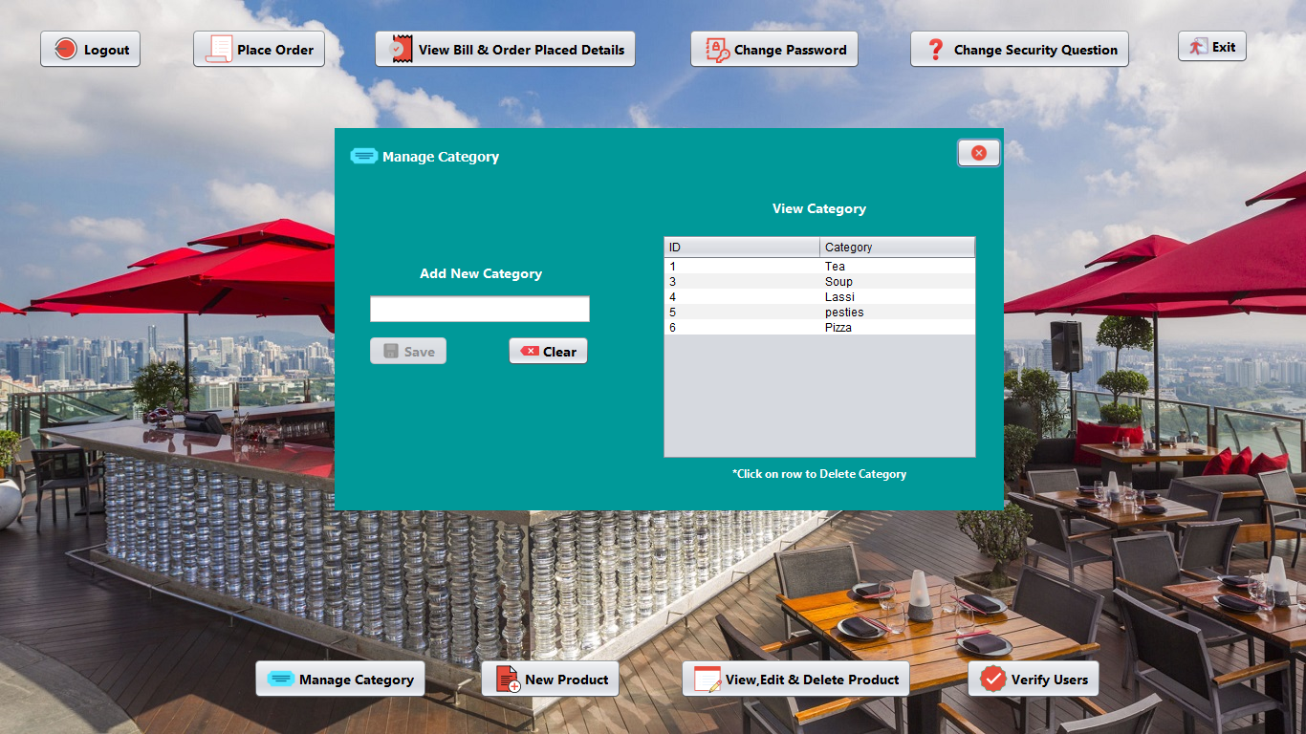

Figure No.:-4

**Manage Category:-**

/*

* Click nbfs://nbhost/SystemFileSystem/Templates/Licenses/license-default.txt to change this license

* Click nbfs://nbhost/SystemFileSystem/Templates/GUIForms/JFrame.java to edit this template

*/

package cafe.management.system;

import model.Category;

import dao.CategoryDao;

import java.util.ArrayList;

import javax.swing.table.DefaultTableModel;

import java.util.*;

import javax.swing.JOptionPane;

import javax.swing.table.TableModel;

/**

*

* @author Amarjeet

*/

public class ManageCategory extends javax.swing.JFrame {

/**

* Creates new form ManageCategory

*/

public ManageCategory() {

initComponents();

btnSave.setEnabled(false);

}

public void validateField()

{

String category=txtName.getText();

if(!category.equals(""))

btnSave.setEnabled(true);

else

btnSave.setEnabled(false);

}

/**

* This method is called from within the constructor to initialize the form.

* WARNING: Do NOT modify this code. The content of this method is always

* regenerated by the Form Editor.

*/

@SuppressWarnings("unchecked")

// <editor-fold defaultstate="collapsed" desc="Generated Code">

private void initComponents() {

jLabel1 = new javax.swing.JLabel();

jButton1 = new javax.swing.JButton();

jLabel2 = new javax.swing.JLabel();

jScrollPane1 = new javax.swing.JScrollPane();

jTable1 = new javax.swing.JTable();

jLabel3 = new javax.swing.JLabel();

jLabel4 = new javax.swing.JLabel();

txtName = new javax.swing.JTextField();

btnSave = new javax.swing.JButton();

btnClear = new javax.swing.JButton();

jLabel5 = new javax.swing.JLabel();

setDefaultCloseOperation(javax.swing.WindowConstants.EXIT_ON_CLOSE);

setLocation(new java.awt.Point(350, 134));

setUndecorated(true);

addComponentListener(new java.awt.event.ComponentAdapter() {

public void componentShown(java.awt.event.ComponentEvent evt) {

formComponentShown(evt);

}

});

getContentPane().setLayout(new org.netbeans.lib.awtextra.AbsoluteLayout());

jLabel1.setFont(new java.awt.Font("Tahoma", 1, 14)); // NOI18N

jLabel1.setForeground(new java.awt.Color(255, 255, 255));

jLabel1.setIcon(new javax.swing.ImageIcon(getClass().getResource("/image/category.png"))); // NOI18N

jLabel1.setText("Manage Category");

getContentPane().add(jLabel1, new org.netbeans.lib.awtextra.AbsoluteConstraints(16, 14, -1, -1));

jButton1.setIcon(new javax.swing.ImageIcon(getClass().getResource("/image/close.png"))); // NOI18N

jButton1.addActionListener(new java.awt.event.ActionListener() {

public void actionPerformed(java.awt.event.ActionEvent evt) {

jButton1ActionPerformed(evt);

}

});

getContentPane().add(jButton1, new org.netbeans.lib.awtextra.AbsoluteConstraints(650, 10, -1, -1));

jLabel2.setFont(new java.awt.Font("Segoe UI", 1, 14)); // NOI18N

jLabel2.setForeground(new java.awt.Color(255, 255, 255));

jLabel2.setText("View Category");

getContentPane().add(jLabel2, new org.netbeans.lib.awtextra.AbsoluteConstraints(458, 73, -1, -1));

jTable1.setModel(new javax.swing.table.DefaultTableModel(

new Object [][] {

},

new String [] {

"ID", "Category"

}

));

jTable1.addMouseListener(new java.awt.event.MouseAdapter() {

public void mouseClicked(java.awt.event.MouseEvent evt) {

jTable1MouseClicked(evt);

}

});

jScrollPane1.setViewportView(jTable1);

getContentPane().add(jScrollPane1, new org.netbeans.lib.awtextra.AbsoluteConstraints(342, 111, 331, 236));

jLabel3.setFont(new java.awt.Font("Segoe UI", 1, 12)); // NOI18N

jLabel3.setForeground(new java.awt.Color(255, 255, 255));

jLabel3.setText("*Click on row to Delete Category");

getContentPane().add(jLabel3, new org.netbeans.lib.awtextra.AbsoluteConstraints(416, 353, -1, -1));

jLabel4.setFont(new java.awt.Font("Segoe UI", 1, 14)); // NOI18N

jLabel4.setForeground(new java.awt.Color(255, 255, 255));

jLabel4.setText("Add New Category");

getContentPane().add(jLabel4, new org.netbeans.lib.awtextra.AbsoluteConstraints(89, 141, -1, -1));

txtName.setFont(new java.awt.Font("Segoe UI", 1, 14)); // NOI18N

txtName.addKeyListener(new java.awt.event.KeyAdapter() {

public void keyReleased(java.awt.event.KeyEvent evt) {

txtNameKeyReleased(evt);

}

});

getContentPane().add(txtName, new org.netbeans.lib.awtextra.AbsoluteConstraints(35, 173, 234, -1));

btnSave.setFont(new java.awt.Font("Segoe UI", 1, 14)); // NOI18N

btnSave.setIcon(new javax.swing.ImageIcon(getClass().getResource("/image/save.png"))); // NOI18N

btnSave.setText("Save");

btnSave.addActionListener(new java.awt.event.ActionListener() {

public void actionPerformed(java.awt.event.ActionEvent evt) {

btnSaveActionPerformed(evt);

}

});

getContentPane().add(btnSave, new org.netbeans.lib.awtextra.AbsoluteConstraints(35, 217, -1, -1));

btnClear.setFont(new java.awt.Font("Segoe UI", 1, 14)); // NOI18N

btnClear.setIcon(new javax.swing.ImageIcon(getClass().getResource("/image/clear.png"))); // NOI18N

btnClear.setText("Clear");

btnClear.addActionListener(new java.awt.event.ActionListener() {

public void actionPerformed(java.awt.event.ActionEvent evt) {

btnClearActionPerformed(evt);

}

});

getContentPane().add(btnClear, new org.netbeans.lib.awtextra.AbsoluteConstraints(180, 217, -1, -1));

jLabel5.setIcon(new javax.swing.ImageIcon(getClass().getResource("/image/small-page-background.png"))); // NOI18N

getContentPane().add(jLabel5, new org.netbeans.lib.awtextra.AbsoluteConstraints(0, 0, 700, 400));

pack();

}// </editor-fold>

private void txtNameKeyReleased(java.awt.event.KeyEvent evt) {

// TODO add your handling code here:

validateField();

}

private void btnSaveActionPerformed(java.awt.event.ActionEvent evt) {

// TODO add your handling code here:

Category category=new Category();

category.setName(txtName.getText());

CategoryDao.save(category);

setVisible(false);

new ManageCategory().setVisible(true);

}

private void formComponentShown(java.awt.event.ComponentEvent evt) {

// TODO add your handling code here:

DefaultTableModel dtm=(DefaultTableModel) jTable1.getModel();

ArrayList<Category> list=CategoryDao.getAllRecords();

Iterator<Category> itr=list.iterator();

while(itr.hasNext())

{

Category categoryObj=itr.next();

dtm.addRow(new Object[] {categoryObj.getId(),categoryObj.getName()});

}

}

private void jTable1MouseClicked(java.awt.event.MouseEvent evt) {

// TODO add your handling code here:

int index=jTable1.getSelectedRow();

TableModel model=jTable1.getModel();

String id=model.getValueAt(index, 0).toString();

String name=model.getValueAt(index, 1).toString();

int a=JOptionPane.showConfirmDialog(null, "Do you want to Delete "+name+"Category","Select",JOptionPane.YES_NO_OPTION);

if(a==0)

{

CategoryDao.delete(id);

setVisible(false);

new ManageCategory().setVisible(true);

}

}

private void btnClearActionPerformed(java.awt.event.ActionEvent evt) {

// TODO add your handling code here:

setVisible(false);

new ManageCategory().setVisible(true);

}

private void jButton1ActionPerformed(java.awt.event.ActionEvent evt) {

// TODO add your handling code here:

setVisible(false);

}

/**

* @param args the command line arguments

*/

public static void main(String args[]) {

/* Set the Nimbus look and feel */

//<editor-fold defaultstate="collapsed" desc=" Look and feel setting code (optional) ">

/* If Nimbus (introduced in Java SE 6) is not available, stay with the default look and feel.

* For details see http://download.oracle.com/javase/tutorial/uiswing/lookandfeel/plaf.html

*/

try {

for (javax.swing.UIManager.LookAndFeelInfo info : javax.swing.UIManager.getInstalledLookAndFeels()) {

if ("Nimbus".equals(info.getName())) {

javax.swing.UIManager.setLookAndFeel(info.getClassName());

break;

}

}

} catch (ClassNotFoundException ex) {

java.util.logging.Logger.getLogger(ManageCategory.class.getName()).log(java.util.logging.Level.SEVERE, null, ex);

} catch (InstantiationException ex) {

java.util.logging.Logger.getLogger(ManageCategory.class.getName()).log(java.util.logging.Level.SEVERE, null, ex);

} catch (IllegalAccessException ex) {

java.util.logging.Logger.getLogger(ManageCategory.class.getName()).log(java.util.logging.Level.SEVERE, null, ex);

} catch (javax.swing.UnsupportedLookAndFeelException ex) {

java.util.logging.Logger.getLogger(ManageCategory.class.getName()).log(java.util.logging.Level.SEVERE, null, ex);

}

//</editor-fold>

/* Create and display the form */

java.awt.EventQueue.invokeLater(new Runnable() {

public void run() {

new ManageCategory().setVisible(true);

}

});

}

// Variables declaration - do not modify

private javax.swing.JButton btnClear;

private javax.swing.JButton btnSave;

private javax.swing.JButton jButton1;

private javax.swing.JLabel jLabel1;

private javax.swing.JLabel jLabel2;

private javax.swing.JLabel jLabel3;

private javax.swing.JLabel jLabel4;

private javax.swing.JLabel jLabel5;

private javax.swing.JScrollPane jScrollPane1;

private javax.swing.JTable jTable1;

private javax.swing.JTextField txtName;

// End of variables declaration

}

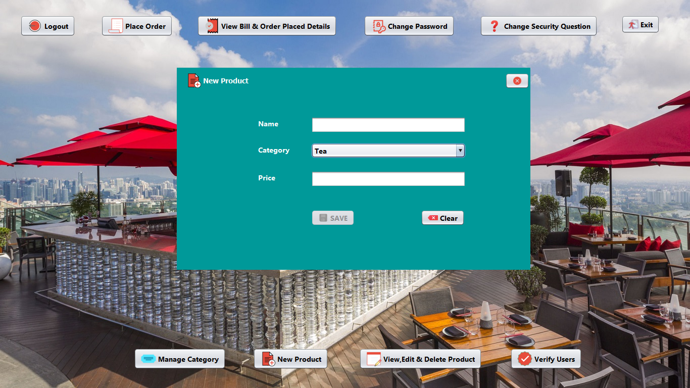

Figure No.:-5

**New Product:-**

/*

* Click nbfs://nbhost/SystemFileSystem/Templates/Licenses/license-default.txt to change this license

* Click nbfs://nbhost/SystemFileSystem/Templates/GUIForms/JFrame.java to edit this template

*/

package cafe.management.system;

import java.util.ArrayList;

import java.util.Iterator;

import model.Category;

import model.Product;

import dao.CategoryDao;

import dao.ProductDao;

/**

*

* @author Amarjeet

*/

public class AddNewProduct extends javax.swing.JFrame {

/**

* Creates new form AddNewProduct

*/

public AddNewProduct() {

initComponents();

btnSave.setEnabled(false);

}

public void validateFields()

{

String name=txtName.getText();

String price=txtPrice.getText();

if(!name.equals("") && !price.equals(""))

btnSave.setEnabled(true);

else

btnSave.setEnabled(false);

}

/**

* This method is called from within the constructor to initialize the form.

* WARNING: Do NOT modify this code. The content of this method is always

* regenerated by the Form Editor.

*/

@SuppressWarnings("unchecked")

// <editor-fold defaultstate="collapsed" desc="Generated Code">

private void initComponents() {

jLabel1 = new javax.swing.JLabel();

jButton1 = new javax.swing.JButton();

jLabel2 = new javax.swing.JLabel();

jLabel3 = new javax.swing.JLabel();

jLabel4 = new javax.swing.JLabel();

txtName = new javax.swing.JTextField();

txtCategory = new javax.swing.JComboBox<>();

txtPrice = new javax.swing.JTextField();

btnSave = new javax.swing.JButton();

btnClear = new javax.swing.JButton();

jLabel5 = new javax.swing.JLabel();

setDefaultCloseOperation(javax.swing.WindowConstants.EXIT_ON_CLOSE);

setLocation(new java.awt.Point(350, 134));

setUndecorated(true);

addComponentListener(new java.awt.event.ComponentAdapter() {

public void componentShown(java.awt.event.ComponentEvent evt) {

formComponentShown(evt);

}

});

getContentPane().setLayout(new org.netbeans.lib.awtextra.AbsoluteLayout());

jLabel1.setFont(new java.awt.Font("Tahoma", 1, 14)); // NOI18N

jLabel1.setForeground(new java.awt.Color(255, 255, 255));

jLabel1.setIcon(new javax.swing.ImageIcon(getClass().getResource("/image/new product.png"))); // NOI18N

jLabel1.setText("New Product");

getContentPane().add(jLabel1, new org.netbeans.lib.awtextra.AbsoluteConstraints(18, 10, -1, -1));

jButton1.setIcon(new javax.swing.ImageIcon(getClass().getResource("/image/close.png"))); // NOI18N

jButton1.addActionListener(new java.awt.event.ActionListener() {

public void actionPerformed(java.awt.event.ActionEvent evt) {

jButton1ActionPerformed(evt);

}

});

getContentPane().add(jButton1, new org.netbeans.lib.awtextra.AbsoluteConstraints(650, 10, -1, -1));

jLabel2.setFont(new java.awt.Font("Segoe UI", 1, 14)); // NOI18N

jLabel2.setForeground(new java.awt.Color(255, 255, 255));

jLabel2.setText("Name");

getContentPane().add(jLabel2, new org.netbeans.lib.awtextra.AbsoluteConstraints(161, 100, -1, -1));

jLabel3.setFont(new java.awt.Font("Segoe UI", 1, 14)); // NOI18N

jLabel3.setForeground(new java.awt.Color(255, 255, 255));

jLabel3.setText("Category");

getContentPane().add(jLabel3, new org.netbeans.lib.awtextra.AbsoluteConstraints(161, 152, -1, -1));

jLabel4.setFont(new java.awt.Font("Segoe UI", 1, 14)); // NOI18N

jLabel4.setForeground(new java.awt.Color(255, 255, 255));

jLabel4.setText("Price");

getContentPane().add(jLabel4, new org.netbeans.lib.awtextra.AbsoluteConstraints(161, 207, -1, -1));

txtName.setFont(new java.awt.Font("Segoe UI", 1, 14)); // NOI18N

txtName.addKeyListener(new java.awt.event.KeyAdapter() {

public void keyReleased(java.awt.event.KeyEvent evt) {

txtNameKeyReleased(evt);

}

});

getContentPane().add(txtName, new org.netbeans.lib.awtextra.AbsoluteConstraints(266, 97, 306, -1));

txtCategory.setFont(new java.awt.Font("Segoe UI", 1, 14)); // NOI18N

getContentPane().add(txtCategory, new org.netbeans.lib.awtextra.AbsoluteConstraints(266, 149, 306, -1));

txtPrice.setFont(new java.awt.Font("Segoe UI", 1, 14)); // NOI18N

txtPrice.addKeyListener(new java.awt.event.KeyAdapter() {

public void keyReleased(java.awt.event.KeyEvent evt) {

txtPriceKeyReleased(evt);

}

});

getContentPane().add(txtPrice, new org.netbeans.lib.awtextra.AbsoluteConstraints(266, 204, 306, -1));

btnSave.setFont(new java.awt.Font("Segoe UI", 1, 14)); // NOI18N

btnSave.setIcon(new javax.swing.ImageIcon(getClass().getResource("/image/save.png"))); // NOI18N

btnSave.setText("SAVE");

btnSave.addActionListener(new java.awt.event.ActionListener() {

public void actionPerformed(java.awt.event.ActionEvent evt) {

btnSaveActionPerformed(evt);

}

});

getContentPane().add(btnSave, new org.netbeans.lib.awtextra.AbsoluteConstraints(266, 281, -1, -1));

btnClear.setFont(new java.awt.Font("Segoe UI", 1, 14)); // NOI18N

btnClear.setIcon(new javax.swing.ImageIcon(getClass().getResource("/image/clear.png"))); // NOI18N

btnClear.setText("Clear");

btnClear.addActionListener(new java.awt.event.ActionListener() {

public void actionPerformed(java.awt.event.ActionEvent evt) {

btnClearActionPerformed(evt);

}

});

getContentPane().add(btnClear, new org.netbeans.lib.awtextra.AbsoluteConstraints(483, 281, -1, -1));

jLabel5.setIcon(new javax.swing.ImageIcon(getClass().getResource("/image/small-page-background.png"))); // NOI18N

jLabel5.setText("jLabel5");

getContentPane().add(jLabel5, new org.netbeans.lib.awtextra.AbsoluteConstraints(0, 0, 700, 400));

pack();

}// </editor-fold>

private void txtNameKeyReleased(java.awt.event.KeyEvent evt) {

// TODO add your handling code here:

validateFields();

}

private void txtPriceKeyReleased(java.awt.event.KeyEvent evt) {

// TODO add your handling code here:

validateFields();

}

private void formComponentShown(java.awt.event.ComponentEvent evt) {

// TODO add your handling code here:

ArrayList<Category> list= CategoryDao.getAllRecords();

Iterator<Category> itr=list.iterator();

while(itr.hasNext())

{

Category categoryObj=itr.next();

txtCategory.addItem(categoryObj.getName());

}

}

private void btnSaveActionPerformed(java.awt.event.ActionEvent evt) {

// TODO add your handling code here:

Product product=new Product();

product.setName(txtName.getText());

product.setCategory((String)txtCategory.getSelectedItem());

product.setPrice(txtPrice.getText());

ProductDao.save(product);

setVisible(false);

new AddNewProduct().setVisible(true);

}

private void btnClearActionPerformed(java.awt.event.ActionEvent evt) {

// TODO add your handling code here:

setVisible(false);

new AddNewProduct().setVisible(true);

}

private void jButton1ActionPerformed(java.awt.event.ActionEvent evt) {

// TODO add your handling code here:

setVisible(false);

}

/**

* @param args the command line arguments

*/

public static void main(String args[]) {

/* Set the Nimbus look and feel */

//<editor-fold defaultstate="collapsed" desc=" Look and feel setting code (optional) ">

/* If Nimbus (introduced in Java SE 6) is not available, stay with the default look and feel.

* For details see http://download.oracle.com/javase/tutorial/uiswing/lookandfeel/plaf.html

*/

try {

for (javax.swing.UIManager.LookAndFeelInfo info : javax.swing.UIManager.getInstalledLookAndFeels()) {

if ("Nimbus".equals(info.getName())) {

javax.swing.UIManager.setLookAndFeel(info.getClassName());

break;

}

}

} catch (ClassNotFoundException ex) {

java.util.logging.Logger.getLogger(AddNewProduct.class.getName()).log(java.util.logging.Level.SEVERE, null, ex);

} catch (InstantiationException ex) {

java.util.logging.Logger.getLogger(AddNewProduct.class.getName()).log(java.util.logging.Level.SEVERE, null, ex);

} catch (IllegalAccessException ex) {

java.util.logging.Logger.getLogger(AddNewProduct.class.getName()).log(java.util.logging.Level.SEVERE, null, ex);

} catch (javax.swing.UnsupportedLookAndFeelException ex) {

java.util.logging.Logger.getLogger(AddNewProduct.class.getName()).log(java.util.logging.Level.SEVERE, null, ex);

}

//</editor-fold>

/* Create and display the form */

java.awt.EventQueue.invokeLater(new Runnable() {

public void run() {

new AddNewProduct().setVisible(true);

}

});

}

// Variables declaration - do not modify

private javax.swing.JButton btnClear;

private javax.swing.JButton btnSave;

private javax.swing.JButton jButton1;

private javax.swing.JLabel jLabel1;

private javax.swing.JLabel jLabel2;

private javax.swing.JLabel jLabel3;

private javax.swing.JLabel jLabel4;

private javax.swing.JLabel jLabel5;

private javax.swing.JComboBox<String> txtCategory;

private javax.swing.JTextField txtName;

private javax.swing.JTextField txtPrice;

// End of variables declaration

}

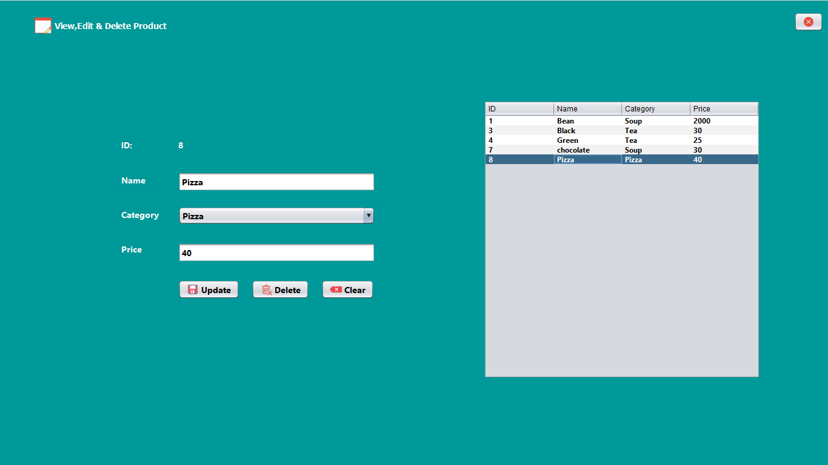

Figure No.:-6

**View, Edit & Delete Product:-**

/*

* Click nbfs://nbhost/SystemFileSystem/Templates/Licenses/license-default.txt to change this license

* Click nbfs://nbhost/SystemFileSystem/Templates/GUIForms/JFrame.java to edit this template

*/

package cafe.management.system;

import dao.CategoryDao;

import model.Product;

import dao.ProductDao;

import java.util.ArrayList;

import java.util.Iterator;

import javax.swing.JOptionPane;

import javax.swing.table.DefaultTableModel;

import javax.swing.table.TableModel;

import model.Category;

/**

*

* @author Amarjeet

*/

public class ViewEditDeleteProduct extends javax.swing.JFrame {

/**

* Creates new form ViewEditDeleteProduct

*/

public ViewEditDeleteProduct() {

initComponents();

btnUpdate.setEnabled(false);

btnDelete.setEnabled(false);

}

public void validateField()

{

String name=txtName.getText();

String price=txtPrice.getText();

String category=(String)jComboBox1.getSelectedItem();

if(!name.equals("")&& !price.equals("")&& category !=null)

btnUpdate.setEnabled(true);

else

btnUpdate.setEnabled(false);

}

/**

* This method is called from within the constructor to initialize the form.

* WARNING: Do NOT modify this code. The content of this method is always

* regenerated by the Form Editor.

*/

@SuppressWarnings("unchecked")

// <editor-fold defaultstate="collapsed" desc="Generated Code">

private void initComponents() {

jLabel1 = new javax.swing.JLabel();

jButton1 = new javax.swing.JButton();

jLabel2 = new javax.swing.JLabel();

jLabel3 = new javax.swing.JLabel();

jLabel4 = new javax.swing.JLabel();

jLabel5 = new javax.swing.JLabel();

lblId = new javax.swing.JLabel();

txtName = new javax.swing.JTextField();

jComboBox1 = new javax.swing.JComboBox<>();

txtPrice = new javax.swing.JTextField();

btnUpdate = new javax.swing.JButton();

btnDelete = new javax.swing.JButton();

btnClear = new javax.swing.JButton();

jScrollPane1 = new javax.swing.JScrollPane();

jTable1 = new javax.swing.JTable();

jLabel7 = new javax.swing.JLabel();

setDefaultCloseOperation(javax.swing.WindowConstants.EXIT_ON_CLOSE);

setUndecorated(true);

addComponentListener(new java.awt.event.ComponentAdapter() {

public void componentShown(java.awt.event.ComponentEvent evt) {

formComponentShown(evt);

}

});

getContentPane().setLayout(new org.netbeans.lib.awtextra.AbsoluteLayout());

jLabel1.setFont(new java.awt.Font("Tahoma", 1, 14)); // NOI18N

jLabel1.setForeground(new java.awt.Color(255, 255, 255));

jLabel1.setIcon(new javax.swing.ImageIcon(getClass().getResource("/image/view edit delete product.png"))); // NOI18N

jLabel1.setText("View,Edit & Delete Product");

getContentPane().add(jLabel1, new org.netbeans.lib.awtextra.AbsoluteConstraints(56, 27, -1, -1));

jButton1.setIcon(new javax.swing.ImageIcon(getClass().getResource("/image/close.png"))); // NOI18N

jButton1.addActionListener(new java.awt.event.ActionListener() {

public void actionPerformed(java.awt.event.ActionEvent evt) {

jButton1ActionPerformed(evt);

}

});

getContentPane().add(jButton1, new org.netbeans.lib.awtextra.AbsoluteConstraints(1310, 20, -1, -1));

jLabel2.setFont(new java.awt.Font("Segoe UI", 1, 14)); // NOI18N

jLabel2.setForeground(new java.awt.Color(255, 255, 255));

jLabel2.setText("ID:");

getContentPane().add(jLabel2, new org.netbeans.lib.awtextra.AbsoluteConstraints(200, 229, -1, -1));

jLabel3.setFont(new java.awt.Font("Segoe UI", 1, 14)); // NOI18N

jLabel3.setForeground(new java.awt.Color(255, 255, 255));

jLabel3.setText("Name");

getContentPane().add(jLabel3, new org.netbeans.lib.awtextra.AbsoluteConstraints(200, 287, -1, -1));

jLabel4.setFont(new java.awt.Font("Segoe UI", 1, 14)); // NOI18N

jLabel4.setForeground(new java.awt.Color(255, 255, 255));

jLabel4.setText("Category");

getContentPane().add(jLabel4, new org.netbeans.lib.awtextra.AbsoluteConstraints(200, 344, -1, -1));

jLabel5.setFont(new java.awt.Font("Segoe UI", 1, 14)); // NOI18N

jLabel5.setForeground(new java.awt.Color(255, 255, 255));

jLabel5.setText("Price");

getContentPane().add(jLabel5, new org.netbeans.lib.awtextra.AbsoluteConstraints(200, 401, -1, -1));

lblId.setFont(new java.awt.Font("Segoe UI", 1, 14)); // NOI18N

lblId.setForeground(new java.awt.Color(255, 255, 255));

lblId.setText("00");

getContentPane().add(lblId, new org.netbeans.lib.awtextra.AbsoluteConstraints(294, 229, -1, -1));

txtName.setFont(new java.awt.Font("Segoe UI", 1, 14)); // NOI18N

txtName.addKeyListener(new java.awt.event.KeyAdapter() {

public void keyReleased(java.awt.event.KeyEvent evt) {

txtNameKeyReleased(evt);

}

});

getContentPane().add(txtName, new org.netbeans.lib.awtextra.AbsoluteConstraints(294, 284, 325, -1));

jComboBox1.setFont(new java.awt.Font("Segoe UI", 1, 14)); // NOI18N

getContentPane().add(jComboBox1, new org.netbeans.lib.awtextra.AbsoluteConstraints(294, 341, 325, -1));

txtPrice.setFont(new java.awt.Font("Segoe UI", 1, 14)); // NOI18N

txtPrice.addKeyListener(new java.awt.event.KeyAdapter() {

public void keyReleased(java.awt.event.KeyEvent evt) {

txtPriceKeyReleased(evt);

}

});

getContentPane().add(txtPrice, new org.netbeans.lib.awtextra.AbsoluteConstraints(294, 401, 325, -1));

btnUpdate.setFont(new java.awt.Font("Segoe UI", 1, 14)); // NOI18N

btnUpdate.setIcon(new javax.swing.ImageIcon(getClass().getResource("/image/save.png"))); // NOI18N

btnUpdate.setText("Update");

btnUpdate.addActionListener(new java.awt.event.ActionListener() {

public void actionPerformed(java.awt.event.ActionEvent evt) {

btnUpdateActionPerformed(evt);

}

});

getContentPane().add(btnUpdate, new org.netbeans.lib.awtextra.AbsoluteConstraints(294, 462, -1, -1));

btnDelete.setFont(new java.awt.Font("Segoe UI", 1, 14)); // NOI18N

btnDelete.setIcon(new javax.swing.ImageIcon(getClass().getResource("/image/delete.png"))); // NOI18N

btnDelete.setText("Delete");

btnDelete.addActionListener(new java.awt.event.ActionListener() {

public void actionPerformed(java.awt.event.ActionEvent evt) {

btnDeleteActionPerformed(evt);

}

});

getContentPane().add(btnDelete, new org.netbeans.lib.awtextra.AbsoluteConstraints(415, 462, -1, -1));

btnClear.setFont(new java.awt.Font("Segoe UI", 1, 14)); // NOI18N

btnClear.setIcon(new javax.swing.ImageIcon(getClass().getResource("/image/clear.png"))); // NOI18N

btnClear.setText("Clear");

btnClear.addActionListener(new java.awt.event.ActionListener() {

public void actionPerformed(java.awt.event.ActionEvent evt) {

btnClearActionPerformed(evt);

}

});

getContentPane().add(btnClear, new org.netbeans.lib.awtextra.AbsoluteConstraints(530, 462, -1, -1));

jTable1.setFont(new java.awt.Font("Segoe UI", 1, 12)); // NOI18N

jTable1.setModel(new javax.swing.table.DefaultTableModel(

new Object [][] {

},

new String [] {

"ID", "Name", "Category", "Price"

}

));

jTable1.addMouseListener(new java.awt.event.MouseAdapter() {

public void mouseClicked(java.awt.event.MouseEvent evt) {

jTable1MouseClicked(evt);

}

});

jScrollPane1.setViewportView(jTable1);

getContentPane().add(jScrollPane1, new org.netbeans.lib.awtextra.AbsoluteConstraints(798, 166, -1, 459));

jLabel7.setIcon(new javax.swing.ImageIcon(getClass().getResource("/image/full-page-background.PNG"))); // NOI18N

getContentPane().add(jLabel7, new org.netbeans.lib.awtextra.AbsoluteConstraints(0, 0, -1, 770));

pack();

}// </editor-fold>

private void txtNameKeyReleased(java.awt.event.KeyEvent evt) {

// TODO add your handling code here:

validateField();

}

private void txtPriceKeyReleased(java.awt.event.KeyEvent evt) {

// TODO add your handling code here:

validateField();

}

private void btnUpdateActionPerformed(java.awt.event.ActionEvent evt) {

// TODO add your handling code here:

Product product=new Product();

int id=Integer.parseInt(lblId.getText());

product.setId(id);

product.setName(txtName.getText());

product.setCategory((String)jComboBox1.getSelectedItem());

product.setPrice(txtPrice.getText());

ProductDao.update(product);

setVisible(false);

new ViewEditDeleteProduct().setVisible(true);

}

private void formComponentShown(java.awt.event.ComponentEvent evt) {

// TODO add your handling code here:

DefaultTableModel dtm=(DefaultTableModel) jTable1.getModel();

ArrayList<Product> list=ProductDao.getAllRecords();

Iterator<Product> itr=list.iterator();

while(itr.hasNext())

{

Product productObj=itr.next();

dtm.addRow(new Object[]{productObj.getId(),productObj.getName(),productObj.getCategory(),productObj.getPrice()});

}

}

private void jTable1MouseClicked(java.awt.event.MouseEvent evt) {

// TODO add your handling code here:

int index=jTable1.getSelectedRow();

TableModel model=jTable1.getModel();

String id=model.getValueAt(index, 0).toString();

lblId.setText(id);

String name=model.getValueAt(index, 1).toString();

txtName.setText(name);

String category=model.getValueAt(index, 2).toString();

String price=model.getValueAt(index, 3).toString();

txtPrice.setText(price);

btnUpdate.setEnabled(true);

btnDelete.setEnabled(true);

jComboBox1.removeAllItems();

jComboBox1.addItem(category);

ArrayList<Category> categoryList=CategoryDao.getAllRecords();

Iterator<Category> categoryItr=categoryList.iterator();

while(categoryItr.hasNext())

{

Category categoryObj=categoryItr.next();

if(!categoryObj.getName().equals(category))

jComboBox1.addItem(categoryObj.getName());

}

}

private void btnDeleteActionPerformed(java.awt.event.ActionEvent evt) {

// TODO add your handling code here:

String id=lblId.getText();

int a=JOptionPane.showConfirmDialog(null, "Do you want to Delete this product","Select",JOptionPane.YES_NO_OPTION);

if(a==0)

{

ProductDao.delete(id);

setVisible(false);

new ViewEditDeleteProduct().setVisible(true);

}

}

private void btnClearActionPerformed(java.awt.event.ActionEvent evt) {

// TODO add your handling code here:

setVisible(false);

new ViewEditDeleteProduct().setVisible(true);

}

private void jButton1ActionPerformed(java.awt.event.ActionEvent evt) {

// TODO add your handling code here:

setVisible(false);

}

/**

* @param args the command line arguments

*/

public static void main(String args[]) {

/* Set the Nimbus look and feel */

//<editor-fold defaultstate="collapsed" desc=" Look and feel setting code (optional) ">

/* If Nimbus (introduced in Java SE 6) is not available, stay with the default look and feel.

* For details see http://download.oracle.com/javase/tutorial/uiswing/lookandfeel/plaf.html

*/

try {

for (javax.swing.UIManager.LookAndFeelInfo info : javax.swing.UIManager.getInstalledLookAndFeels()) {

if ("Nimbus".equals(info.getName())) {

javax.swing.UIManager.setLookAndFeel(info.getClassName());

break;

}

}

} catch (ClassNotFoundException ex) {

java.util.logging.Logger.getLogger(ViewEditDeleteProduct.class.getName()).log(java.util.logging.Level.SEVERE, null, ex);

} catch (InstantiationException ex) {

java.util.logging.Logger.getLogger(ViewEditDeleteProduct.class.getName()).log(java.util.logging.Level.SEVERE, null, ex);

} catch (IllegalAccessException ex) {

java.util.logging.Logger.getLogger(ViewEditDeleteProduct.class.getName()).log(java.util.logging.Level.SEVERE, null, ex);

} catch (javax.swing.UnsupportedLookAndFeelException ex) {

java.util.logging.Logger.getLogger(ViewEditDeleteProduct.class.getName()).log(java.util.logging.Level.SEVERE, null, ex);

}

//</editor-fold>

/* Create and display the form */

java.awt.EventQueue.invokeLater(new Runnable() {

public void run() {

new ViewEditDeleteProduct().setVisible(true);

}

});

}

// Variables declaration - do not modify

private javax.swing.JButton btnClear;

private javax.swing.JButton btnDelete;

private javax.swing.JButton btnUpdate;

private javax.swing.JButton jButton1;

private javax.swing.JComboBox<String> jComboBox1;

private javax.swing.JLabel jLabel1;

private javax.swing.JLabel jLabel2;

private javax.swing.JLabel jLabel3;

private javax.swing.JLabel jLabel4;

private javax.swing.JLabel jLabel5;

private javax.swing.JLabel jLabel7;

private javax.swing.JScrollPane jScrollPane1;

private javax.swing.JTable jTable1;

private javax.swing.JLabel lblId;

private javax.swing.JTextField txtName;

private javax.swing.JTextField txtPrice;

// End of variables declaration

}

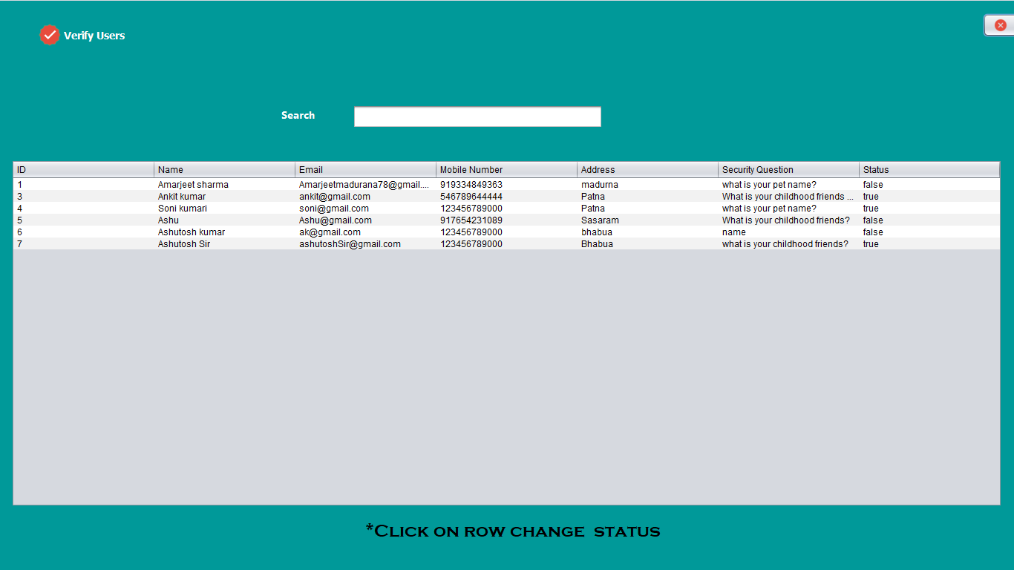

Figure No.:-7

**Verify Users:-**

/*

* Click nbfs://nbhost/SystemFileSystem/Templates/Licenses/license-default.txt to change this license

* Click nbfs://nbhost/SystemFileSystem/Templates/GUIForms/JFrame.java to edit this template

*/

package cafe.management.system;

import javax.swing.table.DefaultTableModel;

import dao.UserDao;

import java.util.ArrayList;

import java.util.Iterator;

import javax.swing.JOptionPane;

import javax.swing.table.TableModel;

import model.User;

/**

*

* @author Amarjeet

*/

public class VerifyUsers extends javax.swing.JFrame {

/**

* Creates new form VerifyUsers

*/

public VerifyUsers() {

initComponents();

}

public void getAllRecords(String email)

{

DefaultTableModel dtm=(DefaultTableModel) jTable1.getModel();

dtm.setRowCount(0);

ArrayList<User> list=UserDao.getAllRecords(email);

Iterator<User> itr=list.iterator();

while(itr.hasNext())

{

User userObj=itr.next();

if(!userObj.getEmail().equals("admin@gmail.com"))

{

dtm.addRow(new Object[]{userObj.getId(),userObj.getName(),userObj.getEmail(),userObj.getMobileNumber(),userObj.getAddress(),userObj.getSecurity(),userObj.getStatus()});

}

}

}

/**

* This method is called from within the constructor to initialize the form.

* WARNING: Do NOT modify this code. The content of this method is always

* regenerated by the Form Editor.

*/

@SuppressWarnings("unchecked")

// <editor-fold defaultstate="collapsed" desc="Generated Code">

private void initComponents() {

jLabel1 = new javax.swing.JLabel();

jButton1 = new javax.swing.JButton();

jLabel2 = new javax.swing.JLabel();

txtEmail = new javax.swing.JTextField();

jScrollPane1 = new javax.swing.JScrollPane();

jTable1 = new javax.swing.JTable();

jLabel3 = new javax.swing.JLabel();

jLabel5 = new javax.swing.JLabel();

setDefaultCloseOperation(javax.swing.WindowConstants.EXIT_ON_CLOSE);

setUndecorated(true);

addComponentListener(new java.awt.event.ComponentAdapter() {

public void componentShown(java.awt.event.ComponentEvent evt) {

formComponentShown(evt);

}

});

getContentPane().setLayout(new org.netbeans.lib.awtextra.AbsoluteLayout());

jLabel1.setFont(new java.awt.Font("Tahoma", 1, 14)); // NOI18N

jLabel1.setForeground(new java.awt.Color(255, 255, 255));

jLabel1.setIcon(new javax.swing.ImageIcon(getClass().getResource("/image/verify users.png"))); // NOI18N

jLabel1.setText("Verify Users");

getContentPane().add(jLabel1, new org.netbeans.lib.awtextra.AbsoluteConstraints(52, 32, -1, -1));

jButton1.setIcon(new javax.swing.ImageIcon(getClass().getResource("/image/close.png"))); // NOI18N

jButton1.addActionListener(new java.awt.event.ActionListener() {

public void actionPerformed(java.awt.event.ActionEvent evt) {

jButton1ActionPerformed(evt);

}

});

getContentPane().add(jButton1, new org.netbeans.lib.awtextra.AbsoluteConstraints(1324, 18, -1, -1));

jLabel2.setFont(new java.awt.Font("Segoe UI", 1, 14)); // NOI18N

jLabel2.setForeground(new java.awt.Color(255, 255, 255));

jLabel2.setText("Search");

getContentPane().add(jLabel2, new org.netbeans.lib.awtextra.AbsoluteConstraints(379, 144, -1, -1));

txtEmail.setFont(new java.awt.Font("Segoe UI", 1, 14)); // NOI18N

txtEmail.addKeyListener(new java.awt.event.KeyAdapter() {

public void keyReleased(java.awt.event.KeyEvent evt) {

txtEmailKeyReleased(evt);

}

});

getContentPane().add(txtEmail, new org.netbeans.lib.awtextra.AbsoluteConstraints(475, 141, 337, -1));

jTable1.setModel(new javax.swing.table.DefaultTableModel(

new Object [][] {

},

new String [] {

"ID", "Name", "Email", "Mobile Number", "Address", "Security Question", "Status"

}

));

jTable1.addMouseListener(new java.awt.event.MouseAdapter() {

public void mouseClicked(java.awt.event.MouseEvent evt) {

jTable1MouseClicked(evt);

}

});

jScrollPane1.setViewportView(jTable1);

getContentPane().add(jScrollPane1, new org.netbeans.lib.awtextra.AbsoluteConstraints(15, 215, 1335, 468));

jLabel3.setFont(new java.awt.Font("Copperplate Gothic Bold", 0, 24)); // NOI18N

jLabel3.setText("*Click on row change status");

getContentPane().add(jLabel3, new org.netbeans.lib.awtextra.AbsoluteConstraints(492, 701, -1, -1));

jLabel5.setIcon(new javax.swing.ImageIcon(getClass().getResource("/image/full-page-background.PNG"))); // NOI18N

getContentPane().add(jLabel5, new org.netbeans.lib.awtextra.AbsoluteConstraints(0, 0, 1370, 770));

pack();

}// </editor-fold>

private void formComponentShown(java.awt.event.ComponentEvent evt) {

// TODO add your handling code here:

getAllRecords("");

}

private void jButton1ActionPerformed(java.awt.event.ActionEvent evt) {

// TODO add your handling code here:

setVisible(false);

}

private void txtEmailKeyReleased(java.awt.event.KeyEvent evt) {

// TODO add your handling code here:

String email=txtEmail.getText();

getAllRecords(email);

}

private void jTable1MouseClicked(java.awt.event.MouseEvent evt) {

// TODO add your handling code here:

int index=jTable1.getSelectedRow();

TableModel model=jTable1.getModel();

String email=model.getValueAt(index, 2).toString();

String status=model.getValueAt(index, 6).toString();

if(status.equals("true"))

status="false";

else

status="true";

int a=JOptionPane.showConfirmDialog(null, "Do you want to change status of "+email+"","Select",JOptionPane.YES_NO_OPTION);

if(a==0)

{

UserDao.changeStatus(email, status);

setVisible(false);

new VerifyUsers().setVisible(true);

}

}

/**

* @param args the command line arguments

*/

public static void main(String args[]) {

/* Set the Nimbus look and feel */

//<editor-fold defaultstate="collapsed" desc=" Look and feel setting code (optional) ">

/* If Nimbus (introduced in Java SE 6) is not available, stay with the default look and feel.

* For details see http://download.oracle.com/javase/tutorial/uiswing/lookandfeel/plaf.html

*/

try {

for (javax.swing.UIManager.LookAndFeelInfo info : javax.swing.UIManager.getInstalledLookAndFeels()) {

if ("Nimbus".equals(info.getName())) {

javax.swing.UIManager.setLookAndFeel(info.getClassName());

break;

}

}

} catch (ClassNotFoundException ex) {

java.util.logging.Logger.getLogger(VerifyUsers.class.getName()).log(java.util.logging.Level.SEVERE, null, ex);

} catch (InstantiationException ex) {

java.util.logging.Logger.getLogger(VerifyUsers.class.getName()).log(java.util.logging.Level.SEVERE, null, ex);

} catch (IllegalAccessException ex) {

java.util.logging.Logger.getLogger(VerifyUsers.class.getName()).log(java.util.logging.Level.SEVERE, null, ex);

} catch (javax.swing.UnsupportedLookAndFeelException ex) {

java.util.logging.Logger.getLogger(VerifyUsers.class.getName()).log(java.util.logging.Level.SEVERE, null, ex);

}

//</editor-fold>

/* Create and display the form */

java.awt.EventQueue.invokeLater(new Runnable() {

public void run() {

new VerifyUsers().setVisible(true);

}

});

}

// Variables declaration - do not modify

private javax.swing.JButton jButton1;

private javax.swing.JLabel jLabel1;

private javax.swing.JLabel jLabel2;

private javax.swing.JLabel jLabel3;

private javax.swing.JLabel jLabel5;

private javax.swing.JScrollPane jScrollPane1;

private javax.swing.JTable jTable1;

private javax.swing.JTextField txtEmail;

// End of variables declaration

}

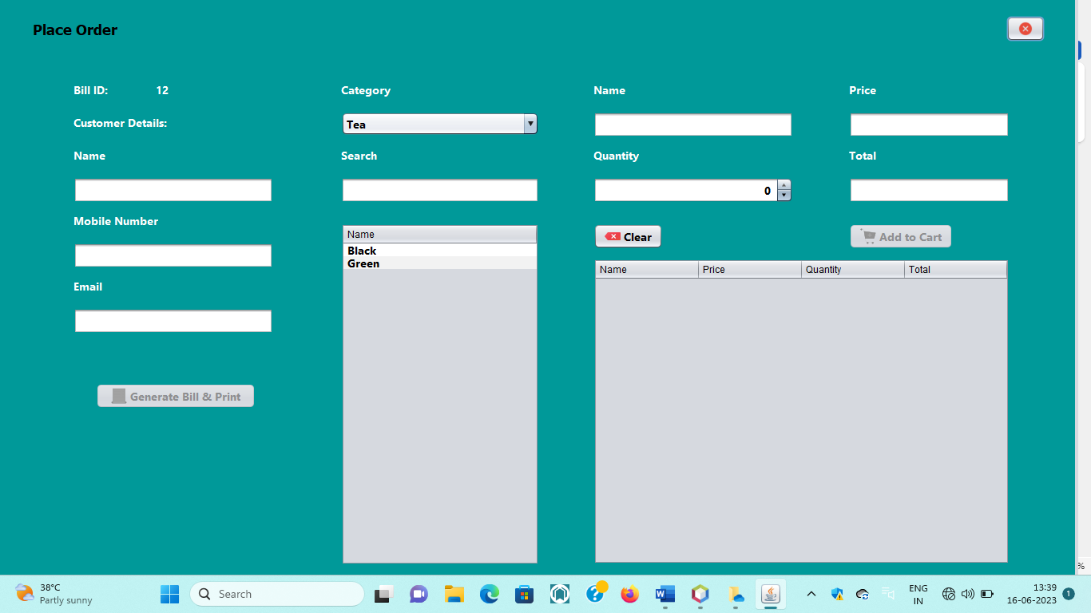

Figure No.:-8

**Place Order:-**

/*

* Click nbfs://nbhost/SystemFileSystem/Templates/Licenses/license-default.txt to change this license

* Click nbfs://nbhost/SystemFileSystem/Templates/GUIForms/JFrame.java to edit this template

*/

package cafe.management.system;

import com.itextpdf.text.Paragraph;

import com.itextpdf.text.pdf.PdfPTable;

import com.itextpdf.text.pdf.PdfWriter;

import common.OpenPdf;

import dao.BillDao;

import dao.CategoryDao;

import dao.ProductDao;

import java.io.FileOutputStream;

import java.text.SimpleDateFormat;

import java.util.ArrayList;

import java.util.Date;

import java.util.Iterator;

import javax.swing.JFormattedTextField;

import javax.swing.JOptionPane;

import javax.swing.JSpinner;

import javax.swing.table.DefaultTableModel;

import model.Category;

import model.Product;

import javax.swing.table.TableModel;

import model.Bill;

/**

*

* @author Amarjeet

*/

public class PlaceOrder extends javax.swing.JFrame {

public int billId=1;

public int grandTotal=0;

public int productPrice=0;

public int productTotal=0;

public String emailPattern="^[a-zA-Z0-9]+[@]+[a-zA-Z0-9]+[.]+[a-zA-Z0-9]+$";

public String mobileNumberPattern="^[0-9]*$";

public String userEmail;

/**

* Creates new form PlaceOrder

*/

public PlaceOrder() {

initComponents();

}

public PlaceOrder(String email) {

initComponents();

txtProName.setEditable(false);

txtProPrice.setEditable(false);

txtProTotal.setEditable(false);

btnAddToCart.setEnabled(false);

btnGenerateBillPrint.setEnabled(false);

JFormattedTextField tf=((JSpinner.DefaultEditor)jSpinner1.getEditor()).getTextField();

tf.setEditable(false);

userEmail=email;

}

public void productNameByCategory(String category)

{

DefaultTableModel dtm=(DefaultTableModel) jTable1.getModel();

dtm.setRowCount(0);

ArrayList<Product> list=ProductDao.getAllRecordsByCategory(category);

Iterator<Product> itr=list.iterator();

while(itr.hasNext())

{

Product productObj=itr.next();

dtm.addRow(new Object[]{productObj.getName()});

}

}

public void filterProductByname(String name,String category)

{

DefaultTableModel dtm=(DefaultTableModel) jTable1.getModel();

dtm.setRowCount(0);

ArrayList<Product> list=ProductDao.filterProductByname(name,category);

Iterator<Product> itr=list.iterator();

while(itr.hasNext())

{

Product productObj=itr.next();

dtm.addRow(new Object[]{productObj.getName()});

}

}

public void clearProductFields()

{

txtProName.setText("");

txtProPrice.setText("");

jSpinner1.setValue(1);

txtProTotal.setText("");

btnAddToCart.setEnabled(false);

}

public void validateField()

{

String customerName=txtCusName.getText();

String customerMobileNumber=txtCusMobileNo.getText();

String customerEmail=txtCusEmail.getText();

if(!customerEmail.equals("")&& customerMobileNumber.matches(mobileNumberPattern)&& customerMobileNumber.length()==10 && customerEmail.matches(emailPattern)&& grandTotal>0)

{

btnGenerateBillPrint.setEnabled(true);

}

else

{

btnGenerateBillPrint.setEnabled(false);

}

}

/**

* This method is called from within the constructor to initialize the form.

* WARNING: Do NOT modify this code. The content of this method is always

* regenerated by the Form Editor.

*/

@SuppressWarnings("unchecked")

// <editor-fold defaultstate="collapsed" desc="Generated Code">

private void initComponents() {

jLabel1 = new javax.swing.JLabel();

jButton1 = new javax.swing.JButton();

jLabel2 = new javax.swing.JLabel();

jLabel3 = new javax.swing.JLabel();

jLabel4 = new javax.swing.JLabel();

jLabel5 = new javax.swing.JLabel();

txtCusName = new javax.swing.JTextField();

jLabel6 = new javax.swing.JLabel();

txtCusMobileNo = new javax.swing.JTextField();

jLabel7 = new javax.swing.JLabel();

txtCusEmail = new javax.swing.JTextField();

jLabel8 = new javax.swing.JLabel();

jComboBox1 = new javax.swing.JComboBox<>();

jLabel9 = new javax.swing.JLabel();

txtSearch = new javax.swing.JTextField();

jScrollPane1 = new javax.swing.JScrollPane();

jTable1 = new javax.swing.JTable();

jLabel10 = new javax.swing.JLabel();

txtProName = new javax.swing.JTextField();

jLabel11 = new javax.swing.JLabel();

txtProPrice = new javax.swing.JTextField();

jLabel12 = new javax.swing.JLabel();

jSpinner1 = new javax.swing.JSpinner();

jLabel13 = new javax.swing.JLabel();

txtProTotal = new javax.swing.JTextField();

btnClear = new javax.swing.JButton();

btnAddToCart = new javax.swing.JButton();

jScrollPane2 = new javax.swing.JScrollPane();

jTable2 = new javax.swing.JTable();

jLabel14 = new javax.swing.JLabel();

lblGrandTotal = new javax.swing.JLabel();

btnGenerateBillPrint = new javax.swing.JButton();

jLabel16 = new javax.swing.JLabel();

setDefaultCloseOperation(javax.swing.WindowConstants.EXIT_ON_CLOSE);

setUndecorated(true);

addComponentListener(new java.awt.event.ComponentAdapter() {

public void componentShown(java.awt.event.ComponentEvent evt) {

formComponentShown(evt);

}

});

getContentPane().setLayout(new org.netbeans.lib.awtextra.AbsoluteLayout());

jLabel1.setFont(new java.awt.Font("Tahoma", 1, 18)); // NOI18N

jLabel1.setText("Place Order");

getContentPane().add(jLabel1, new org.netbeans.lib.awtextra.AbsoluteConstraints(41, 26, -1, -1));

jButton1.setIcon(new javax.swing.ImageIcon(getClass().getResource("/image/close.png"))); // NOI18N

jButton1.addActionListener(new java.awt.event.ActionListener() {

public void actionPerformed(java.awt.event.ActionEvent evt) {

jButton1ActionPerformed(evt);

}

});

getContentPane().add(jButton1, new org.netbeans.lib.awtextra.AbsoluteConstraints(1260, 20, -1, -1));

jLabel2.setFont(new java.awt.Font("Segoe UI", 1, 14)); // NOI18N

jLabel2.setForeground(new java.awt.Color(255, 255, 255));

jLabel2.setText("Bill ID:");

getContentPane().add(jLabel2, new org.netbeans.lib.awtextra.AbsoluteConstraints(92, 102, -1, -1));

jLabel3.setFont(new java.awt.Font("Segoe UI", 1, 14)); // NOI18N

jLabel3.setForeground(new java.awt.Color(255, 255, 255));

jLabel3.setText("--");

getContentPane().add(jLabel3, new org.netbeans.lib.awtextra.AbsoluteConstraints(195, 102, -1, -1));

jLabel4.setFont(new java.awt.Font("Segoe UI", 1, 14)); // NOI18N

jLabel4.setForeground(new java.awt.Color(255, 255, 255));

jLabel4.setText("Customer Details:");

getContentPane().add(jLabel4, new org.netbeans.lib.awtextra.AbsoluteConstraints(92, 143, -1, -1));

jLabel5.setFont(new java.awt.Font("Segoe UI", 1, 14)); // NOI18N

jLabel5.setForeground(new java.awt.Color(255, 255, 255));

jLabel5.setText("Name");

getContentPane().add(jLabel5, new org.netbeans.lib.awtextra.AbsoluteConstraints(92, 184, -1, -1));

txtCusName.setFont(new java.awt.Font("Segoe UI", 1, 14)); // NOI18N

txtCusName.addKeyListener(new java.awt.event.KeyAdapter() {

public void keyReleased(java.awt.event.KeyEvent evt) {

txtCusNameKeyReleased(evt);

}

});

getContentPane().add(txtCusName, new org.netbeans.lib.awtextra.AbsoluteConstraints(92, 222, 250, -1));

jLabel6.setFont(new java.awt.Font("Segoe UI", 1, 14)); // NOI18N

jLabel6.setForeground(new java.awt.Color(255, 255, 255));

jLabel6.setText("Mobile Number");

getContentPane().add(jLabel6, new org.netbeans.lib.awtextra.AbsoluteConstraints(92, 266, -1, -1));

txtCusMobileNo.setFont(new java.awt.Font("Segoe UI", 1, 14)); // NOI18N

txtCusMobileNo.addKeyListener(new java.awt.event.KeyAdapter() {

public void keyReleased(java.awt.event.KeyEvent evt) {

txtCusMobileNoKeyReleased(evt);

}

});

getContentPane().add(txtCusMobileNo, new org.netbeans.lib.awtextra.AbsoluteConstraints(92, 304, 250, -1));

jLabel7.setFont(new java.awt.Font("Segoe UI", 1, 14)); // NOI18N

jLabel7.setForeground(new java.awt.Color(255, 255, 255));

jLabel7.setText("Email");

getContentPane().add(jLabel7, new org.netbeans.lib.awtextra.AbsoluteConstraints(92, 348, -1, -1));

txtCusEmail.setFont(new java.awt.Font("Segoe UI", 1, 14)); // NOI18N

txtCusEmail.addKeyListener(new java.awt.event.KeyAdapter() {

public void keyReleased(java.awt.event.KeyEvent evt) {

txtCusEmailKeyReleased(evt);

}

});

getContentPane().add(txtCusEmail, new org.netbeans.lib.awtextra.AbsoluteConstraints(92, 386, 250, -1));

jLabel8.setFont(new java.awt.Font("Segoe UI", 1, 14)); // NOI18N

jLabel8.setForeground(new java.awt.Color(255, 255, 255));

jLabel8.setText("Category");

getContentPane().add(jLabel8, new org.netbeans.lib.awtextra.AbsoluteConstraints(427, 102, -1, -1));

jComboBox1.setFont(new java.awt.Font("Segoe UI", 1, 14)); // NOI18N

jComboBox1.addActionListener(new java.awt.event.ActionListener() {

public void actionPerformed(java.awt.event.ActionEvent evt) {

jComboBox1ActionPerformed(evt);

}

});

getContentPane().add(jComboBox1, new org.netbeans.lib.awtextra.AbsoluteConstraints(427, 140, 248, -1));

jLabel9.setFont(new java.awt.Font("Segoe UI", 1, 14)); // NOI18N

jLabel9.setForeground(new java.awt.Color(255, 255, 255));

jLabel9.setText("Search");

getContentPane().add(jLabel9, new org.netbeans.lib.awtextra.AbsoluteConstraints(427, 184, -1, -1));

txtSearch.setFont(new java.awt.Font("Segoe UI", 1, 14)); // NOI18N

txtSearch.addKeyListener(new java.awt.event.KeyAdapter() {

public void keyReleased(java.awt.event.KeyEvent evt) {

txtSearchKeyReleased(evt);

}

});

getContentPane().add(txtSearch, new org.netbeans.lib.awtextra.AbsoluteConstraints(427, 222, 248, -1));

jTable1.setFont(new java.awt.Font("Segoe UI", 1, 14)); // NOI18N

jTable1.setModel(new javax.swing.table.DefaultTableModel(

new Object [][] {

},

new String [] {

"Name"

}

));

jTable1.addMouseListener(new java.awt.event.MouseAdapter() {

public void mouseClicked(java.awt.event.MouseEvent evt) {

jTable1MouseClicked(evt);

}

});

jScrollPane1.setViewportView(jTable1);

getContentPane().add(jScrollPane1, new org.netbeans.lib.awtextra.AbsoluteConstraints(427, 280, 248, -1));

jLabel10.setFont(new java.awt.Font("Segoe UI", 1, 14)); // NOI18N

jLabel10.setForeground(new java.awt.Color(255, 255, 255));

jLabel10.setText("Name");

getContentPane().add(jLabel10, new org.netbeans.lib.awtextra.AbsoluteConstraints(743, 102, -1, -1));

txtProName.setFont(new java.awt.Font("Segoe UI", 1, 14)); // NOI18N

getContentPane().add(txtProName, new org.netbeans.lib.awtextra.AbsoluteConstraints(743, 140, 250, -1));

jLabel11.setFont(new java.awt.Font("Segoe UI", 1, 14)); // NOI18N

jLabel11.setForeground(new java.awt.Color(255, 255, 255));

jLabel11.setText("Price");

getContentPane().add(jLabel11, new org.netbeans.lib.awtextra.AbsoluteConstraints(1063, 102, -1, -1));

txtProPrice.setFont(new java.awt.Font("Segoe UI", 1, 14)); // NOI18N

getContentPane().add(txtProPrice, new org.netbeans.lib.awtextra.AbsoluteConstraints(1063, 140, 201, -1));

jLabel12.setFont(new java.awt.Font("Segoe UI", 1, 14)); // NOI18N

jLabel12.setForeground(new java.awt.Color(255, 255, 255));

jLabel12.setText("Quantity");

getContentPane().add(jLabel12, new org.netbeans.lib.awtextra.AbsoluteConstraints(743, 184, -1, -1));

jSpinner1.setFont(new java.awt.Font("Segoe UI", 1, 14)); // NOI18N

jSpinner1.addChangeListener(new javax.swing.event.ChangeListener() {

public void stateChanged(javax.swing.event.ChangeEvent evt) {

jSpinner1StateChanged(evt);

}

});

getContentPane().add(jSpinner1, new org.netbeans.lib.awtextra.AbsoluteConstraints(743, 222, 250, -1));

jLabel13.setFont(new java.awt.Font("Segoe UI", 1, 14)); // NOI18N

jLabel13.setForeground(new java.awt.Color(255, 255, 255));

jLabel13.setText("Total");

getContentPane().add(jLabel13, new org.netbeans.lib.awtextra.AbsoluteConstraints(1063, 184, -1, -1));

txtProTotal.setFont(new java.awt.Font("Segoe UI", 1, 14)); // NOI18N

getContentPane().add(txtProTotal, new org.netbeans.lib.awtextra.AbsoluteConstraints(1063, 222, 201, -1));

btnClear.setFont(new java.awt.Font("Segoe UI", 1, 14)); // NOI18N

btnClear.setIcon(new javax.swing.ImageIcon(getClass().getResource("/image/clear.png"))); // NOI18N

btnClear.setText("Clear");

btnClear.addActionListener(new java.awt.event.ActionListener() {

public void actionPerformed(java.awt.event.ActionEvent evt) {

btnClearActionPerformed(evt);

}

});

getContentPane().add(btnClear, new org.netbeans.lib.awtextra.AbsoluteConstraints(743, 280, -1, -1));

btnAddToCart.setFont(new java.awt.Font("Segoe UI", 1, 14)); // NOI18N

btnAddToCart.setIcon(new javax.swing.ImageIcon(getClass().getResource("/image/add to cart.png"))); // NOI18N

btnAddToCart.setText("Add to Cart");

btnAddToCart.addActionListener(new java.awt.event.ActionListener() {

public void actionPerformed(java.awt.event.ActionEvent evt) {

btnAddToCartActionPerformed(evt);

}

});

getContentPane().add(btnAddToCart, new org.netbeans.lib.awtextra.AbsoluteConstraints(1063, 280, -1, -1));

jTable2.setFont(new java.awt.Font("Segoe UI", 1, 14)); // NOI18N

jTable2.setModel(new javax.swing.table.DefaultTableModel(

new Object [][] {

},

new String [] {

"Name", "Price", "Quantity", "Total"

}

));

jTable2.addMouseListener(new java.awt.event.MouseAdapter() {

public void mouseClicked(java.awt.event.MouseEvent evt) {

jTable2MouseClicked(evt);

}

});

jScrollPane2.setViewportView(jTable2);

getContentPane().add(jScrollPane2, new org.netbeans.lib.awtextra.AbsoluteConstraints(743, 324, 521, 383));

jLabel14.setFont(new java.awt.Font("Segoe UI", 1, 14)); // NOI18N

jLabel14.setForeground(new java.awt.Color(255, 255, 255));

jLabel14.setText("Grand Total Rs.");

getContentPane().add(jLabel14, new org.netbeans.lib.awtextra.AbsoluteConstraints(740, 720, 130, -1));

lblGrandTotal.setFont(new java.awt.Font("Segoe UI", 1, 14)); // NOI18N

lblGrandTotal.setForeground(new java.awt.Color(255, 255, 255));

lblGrandTotal.setText("000");

getContentPane().add(lblGrandTotal, new org.netbeans.lib.awtextra.AbsoluteConstraints(850, 720, 40, -1));

btnGenerateBillPrint.setFont(new java.awt.Font("Segoe UI", 1, 14)); // NOI18N

btnGenerateBillPrint.setIcon(new javax.swing.ImageIcon(getClass().getResource("/image/generate bill & print.png"))); // NOI18N

btnGenerateBillPrint.setText("Generate Bill & Print");

btnGenerateBillPrint.addActionListener(new java.awt.event.ActionListener() {

public void actionPerformed(java.awt.event.ActionEvent evt) {

btnGenerateBillPrintActionPerformed(evt);

}

});

getContentPane().add(btnGenerateBillPrint, new org.netbeans.lib.awtextra.AbsoluteConstraints(120, 480, 200, -1));

jLabel16.setForeground(new java.awt.Color(255, 255, 255));

jLabel16.setIcon(new javax.swing.ImageIcon(getClass().getResource("/image/full-page-background.PNG"))); // NOI18N

getContentPane().add(jLabel16, new org.netbeans.lib.awtextra.AbsoluteConstraints(-20, 0, 1370, -1));

pack();

}// </editor-fold>

private void jButton1ActionPerformed(java.awt.event.ActionEvent evt) {

// TODO add your handling code here:

setVisible(false);

new Home(userEmail).setVisible(true);

}

private void formComponentShown(java.awt.event.ComponentEvent evt) {

// TODO add your handling code here:

billId=Integer.parseInt(BillDao.getId());

jLabel3.setText(BillDao.getId());

ArrayList<Category> list=CategoryDao.getAllRecords();

Iterator<Category> itr=list.iterator();

while(itr.hasNext())

{

Category categoryObj=itr.next();

jComboBox1.addItem(categoryObj.getName());

}

String category=(String) jComboBox1.getSelectedItem();

productNameByCategory(category);

}

private void txtSearchKeyReleased(java.awt.event.KeyEvent evt) {

// TODO add your handling code here:

String name=txtSearch.getText();

String category=(String) jComboBox1.getSelectedItem();

filterProductByname(name,category);

}

private void jTable1MouseClicked(java.awt.event.MouseEvent evt) {

// TODO add your handling code here:

int index=jTable1.getSelectedRow();

TableModel model=jTable1.getModel();

String productName=model.getValueAt(index, 0).toString();

Product product=ProductDao.getProductByname(productName);

txtProName.setText(product.getName());

txtProPrice.setText(product.getPrice());

jSpinner1.setValue(1);

txtProTotal.setText(product.getPrice());

productPrice=Integer.parseInt(product.getPrice());

productTotal=Integer.parseInt(product.getPrice());

btnAddToCart.setEnabled(true);

}

private void jSpinner1StateChanged(javax.swing.event.ChangeEvent evt) {

// TODO add your handling code here:

int quantity=(Integer)jSpinner1.getValue();

if(quantity<=1)

{

jSpinner1.setValue(1);

quantity=1;

}

productTotal=productPrice*quantity;

txtProTotal.setText(String.valueOf(productTotal));

}

private void jComboBox1ActionPerformed(java.awt.event.ActionEvent evt) {

// TODO add your handling code here:

String category=(String)jComboBox1.getSelectedItem();

productNameByCategory(category);

}

private void btnAddToCartActionPerformed(java.awt.event.ActionEvent evt) {

// TODO add your handling code here:

String name=txtProName.getText();

String price=txtProPrice.getText();

String quantity=String.valueOf(jSpinner1.getValue());

DefaultTableModel dtm=(DefaultTableModel) jTable2.getModel();

dtm.addRow(new Object[] {name,price,quantity,productTotal});

grandTotal=grandTotal+productTotal;

lblGrandTotal.setText(String.valueOf(grandTotal));

clearProductFields();

validateField();

}

private void btnClearActionPerformed(java.awt.event.ActionEvent evt) {

// TODO add your handling code here:

clearProductFields();

}

private void txtCusNameKeyReleased(java.awt.event.KeyEvent evt) {

// TODO add your handling code here:

validateField();

}

private void txtCusMobileNoKeyReleased(java.awt.event.KeyEvent evt) {

// TODO add your handling code here:

validateField();

}

private void txtCusEmailKeyReleased(java.awt.event.KeyEvent evt) {

// TODO add your handling code here:

validateField();

}

private void btnGenerateBillPrintActionPerformed(java.awt.event.ActionEvent evt) {

// TODO add your handling code here:

String customerName=txtCusName.getText();

String customerMobileNumber=txtCusMobileNo.getText();

String customerEmail=txtCusEmail.getText();

SimpleDateFormat dFormat=new SimpleDateFormat("dd-MM-yyyy");

Date date=new Date();

String todaydate=dFormat.format(date);

String total=String.valueOf(grandTotal);

String createdBy=userEmail;

Bill bill=new Bill();

bill.setId(billId);

bill.setName(customerName);

bill.setMobileNumber(customerMobileNumber);

bill.setEmail(customerEmail);

bill.setDate(todaydate);

bill.setTotal(total);

bill.setCreatedBy(createdBy);

BillDao.save(bill);

// Creating document

String path="F:\\";

com.itextpdf.text.Document doc=new com.itextpdf.text.Document();

try

{

PdfWriter.getInstance(doc, new FileOutputStream(path + "" + billId +".pdf"));

doc.open();

Paragraph cafeName=new Paragraph(" Restaurant Management System\n");

doc.add(cafeName);

Paragraph starLine=new Paragraph("************************************************************************************************************************************");

doc.add(starLine);

Paragraph paragraph3=new Paragraph("\tBill ID: "+billId+"\nCustomer Name: "+customerName+"\nTotal Paid: "+grandTotal);

doc.add(paragraph3);

doc.add(starLine);

PdfPTable tb1=new PdfPTable(4);

tb1.addCell("Name");

tb1.addCell("Price");

tb1.addCell("Quantity");

tb1.addCell("Total");

for(int i=0;i<jTable2.getRowCount();i++)

{

String n=jTable2.getValueAt(i, 0).toString();

String d=jTable2.getValueAt(i, 1).toString();

String r=jTable2.getValueAt(i, 2).toString();

String q=jTable2.getValueAt(i, 3).toString();

tb1.addCell(n);

tb1.addCell(d);

tb1.addCell(r);

tb1.addCell(q);

}

doc.add(tb1);

doc.add(starLine);

Paragraph thanksMsg=new Paragraph(" Thank You! Please visit Again.");

doc.add(thanksMsg);

//open pdf

OpenPdf.openById(String.valueOf(billId));

}

catch(Exception e)

{

JOptionPane.showMessageDialog(null, e);

}

doc.close();

setVisible(false);

new PlaceOrder(createdBy).setVisible(true);

}

private void jTable2MouseClicked(java.awt.event.MouseEvent evt) {

// TODO add your handling code here:

int index=jTable2.getSelectedRow();

int a=JOptionPane.showConfirmDialog(null, "Do you want to remove this product","Select",JOptionPane.YES_NO_OPTION);

if(a==0)

{

TableModel model=jTable2.getModel();

String total=model.getValueAt(index, 3).toString();

grandTotal=grandTotal-Integer.parseInt(total);

lblGrandTotal.setText(String.valueOf(grandTotal));

((DefaultTableModel)jTable2.getModel()).removeRow(index);

}

}

/**

* @param args the command line arguments

*/

public static void main(String args[]) {

/* Set the Nimbus look and feel */

//<editor-fold defaultstate="collapsed" desc=" Look and feel setting code (optional) ">

/* If Nimbus (introduced in Java SE 6) is not available, stay with the default look and feel.

* For details see http://download.oracle.com/javase/tutorial/uiswing/lookandfeel/plaf.html

*/

try {

for (javax.swing.UIManager.LookAndFeelInfo info : javax.swing.UIManager.getInstalledLookAndFeels()) {

if ("Nimbus".equals(info.getName())) {

javax.swing.UIManager.setLookAndFeel(info.getClassName());

break;

}

}

} catch (ClassNotFoundException ex) {

java.util.logging.Logger.getLogger(PlaceOrder.class.getName()).log(java.util.logging.Level.SEVERE, null, ex);

} catch (InstantiationException ex) {

java.util.logging.Logger.getLogger(PlaceOrder.class.getName()).log(java.util.logging.Level.SEVERE, null, ex);

} catch (IllegalAccessException ex) {

java.util.logging.Logger.getLogger(PlaceOrder.class.getName()).log(java.util.logging.Level.SEVERE, null, ex);

} catch (javax.swing.UnsupportedLookAndFeelException ex) {

java.util.logging.Logger.getLogger(PlaceOrder.class.getName()).log(java.util.logging.Level.SEVERE, null, ex);

}

//</editor-fold>

/* Create and display the form */

java.awt.EventQueue.invokeLater(new Runnable() {

public void run() {

new PlaceOrder().setVisible(true);

}

});

}

// Variables declaration - do not modify

private javax.swing.JButton btnAddToCart;

private javax.swing.JButton btnClear;

private javax.swing.JButton btnGenerateBillPrint;

private javax.swing.JButton jButton1;

private javax.swing.JComboBox<String> jComboBox1;

private javax.swing.JLabel jLabel1;

private javax.swing.JLabel jLabel10;

private javax.swing.JLabel jLabel11;

private javax.swing.JLabel jLabel12;

private javax.swing.JLabel jLabel13;

private javax.swing.JLabel jLabel14;

private javax.swing.JLabel jLabel16;

private javax.swing.JLabel jLabel2;

private javax.swing.JLabel jLabel3;

private javax.swing.JLabel jLabel4;

private javax.swing.JLabel jLabel5;

private javax.swing.JLabel jLabel6;

private javax.swing.JLabel jLabel7;

private javax.swing.JLabel jLabel8;

private javax.swing.JLabel jLabel9;

private javax.swing.JScrollPane jScrollPane1;

private javax.swing.JScrollPane jScrollPane2;

private javax.swing.JSpinner jSpinner1;

private javax.swing.JTable jTable1;

private javax.swing.JTable jTable2;

private javax.swing.JLabel lblGrandTotal;

private javax.swing.JTextField txtCusEmail;

private javax.swing.JTextField txtCusMobileNo;

private javax.swing.JTextField txtCusName;

private javax.swing.JTextField txtProName;

private javax.swing.JTextField txtProPrice;

private javax.swing.JTextField txtProTotal;

private javax.swing.JTextField txtSearch;

// End of variables declaration

}

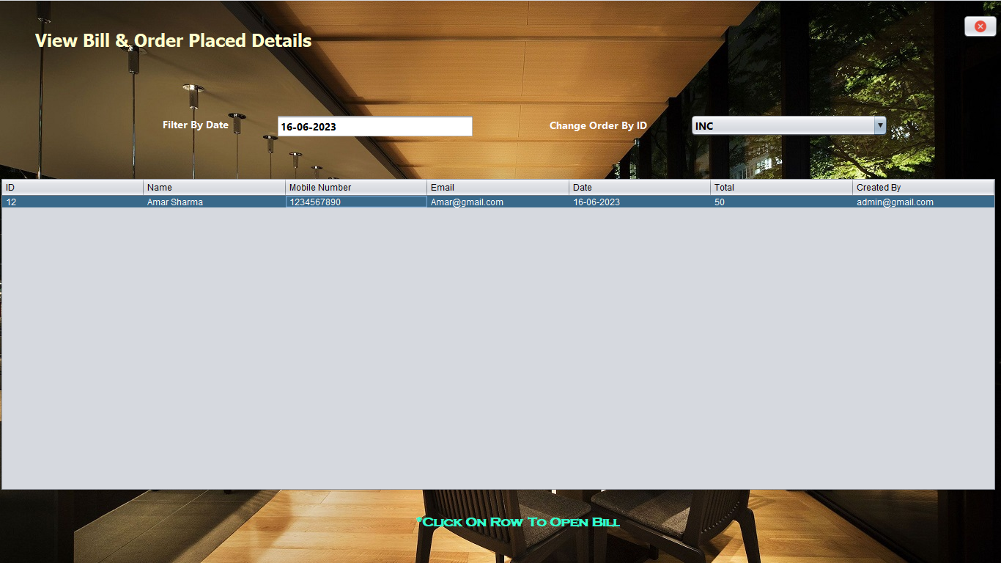

Figure No.:-9

**View Bill & Order Placed Details:-**

/*

* Click nbfs://nbhost/SystemFileSystem/Templates/Licenses/license-default.txt to change this license

* Click nbfs://nbhost/SystemFileSystem/Templates/GUIForms/JFrame.java to edit this template

*/

package cafe.management.system;

import common.OpenPdf;

import dao.BillDao;

import java.text.SimpleDateFormat;

import java.util.ArrayList;

import java.util.Date;

import java.util.Iterator;

import javax.swing.table.DefaultTableModel;

import javax.swing.table.TableModel;

import model.Bill;

/**

*

* @author Amarjeet

*/

public class ViewBillOrderPlacedDetails extends javax.swing.JFrame {

/**

* Creates new form ViewBillOrderPlacedDetails

*/

public ViewBillOrderPlacedDetails() {

initComponents();

SimpleDateFormat dFormat=new SimpleDateFormat("dd-MM-yyyy");

Date date=new Date();

String todayDate=dFormat.format(date);

jTextField1.setText(todayDate);

}

public void tableDetails()

{

String date=jTextField1.getText();

String incDec=(String) jComboBox1.getSelectedItem();

DefaultTableModel dtm=(DefaultTableModel) jTable1.getModel();

dtm.setRowCount(0);

if(incDec.equals("INC"))

{

ArrayList<Bill> list=BillDao.getAllRecordsByInc(date);

Iterator<Bill> itr=list.iterator();

while(itr.hasNext())

{

Bill billObj=itr.next();

dtm.addRow(new Object[]{billObj.getId(),billObj.getName(),billObj.getMobileNumber(),billObj.getEmail(),billObj.getDate(),billObj.getTotal(),billObj.getCreatedBy()});

}

}

else

{

ArrayList<Bill> list=BillDao.getAllRecordsByDesc(date);

Iterator<Bill> itr=list.iterator();

while(itr.hasNext())

{

Bill billObj=itr.next();

dtm.addRow(new Object[]{billObj.getId(),billObj.getName(),billObj.getMobileNumber(),billObj.getEmail(),billObj.getDate(),billObj.getTotal(),billObj.getCreatedBy()});

}

}

}

/**

* This method is called from within the constructor to initialize the form.

* WARNING: Do NOT modify this code. The content of this method is always

* regenerated by the Form Editor.

*/

@SuppressWarnings("unchecked")

// <editor-fold defaultstate="collapsed" desc="Generated Code">

private void initComponents() {

jLabel1 = new javax.swing.JLabel();

jButton1 = new javax.swing.JButton();

jLabel2 = new javax.swing.JLabel();

jTextField1 = new javax.swing.JTextField();

jLabel3 = new javax.swing.JLabel();

jComboBox1 = new javax.swing.JComboBox<>();

jScrollPane1 = new javax.swing.JScrollPane();

jTable1 = new javax.swing.JTable();

jLabel4 = new javax.swing.JLabel();

jLabel5 = new javax.swing.JLabel();

setDefaultCloseOperation(javax.swing.WindowConstants.EXIT_ON_CLOSE);

setUndecorated(true);

addComponentListener(new java.awt.event.ComponentAdapter() {

public void componentShown(java.awt.event.ComponentEvent evt) {

formComponentShown(evt);

}

});

getContentPane().setLayout(new org.netbeans.lib.awtextra.AbsoluteLayout());

jLabel1.setFont(new java.awt.Font("Tahoma", 1, 24)); // NOI18N

jLabel1.setForeground(new java.awt.Color(255, 255, 204));

jLabel1.setText("View Bill & Order Placed Details");

getContentPane().add(jLabel1, new org.netbeans.lib.awtextra.AbsoluteConstraints(48, 40, -1, -1));

jButton1.setIcon(new javax.swing.ImageIcon(getClass().getResource("/image/close.png"))); // NOI18N

jButton1.addActionListener(new java.awt.event.ActionListener() {

public void actionPerformed(java.awt.event.ActionEvent evt) {

jButton1ActionPerformed(evt);

}

});

getContentPane().add(jButton1, new org.netbeans.lib.awtextra.AbsoluteConstraints(1314, 20, -1, -1));

jLabel2.setFont(new java.awt.Font("Segoe UI", 1, 14)); // NOI18N

jLabel2.setForeground(new java.awt.Color(255, 255, 255));

jLabel2.setText("Filter By Date");

getContentPane().add(jLabel2, new org.netbeans.lib.awtextra.AbsoluteConstraints(222, 159, -1, -1));

jTextField1.setFont(new java.awt.Font("Segoe UI", 1, 14)); // NOI18N

jTextField1.addActionListener(new java.awt.event.ActionListener() {

public void actionPerformed(java.awt.event.ActionEvent evt) {

jTextField1ActionPerformed(evt);

}

});

jTextField1.addKeyListener(new java.awt.event.KeyAdapter() {

public void keyReleased(java.awt.event.KeyEvent evt) {

jTextField1KeyReleased(evt);

}

});

getContentPane().add(jTextField1, new org.netbeans.lib.awtextra.AbsoluteConstraints(377, 156, 270, -1));

jLabel3.setFont(new java.awt.Font("Segoe UI", 1, 14)); // NOI18N

jLabel3.setForeground(new java.awt.Color(255, 255, 255));

jLabel3.setText("Change Order By ID");

getContentPane().add(jLabel3, new org.netbeans.lib.awtextra.AbsoluteConstraints(750, 160, -1, -1));

jComboBox1.setFont(new java.awt.Font("Segoe UI", 1, 14)); // NOI18N

jComboBox1.setModel(new javax.swing.DefaultComboBoxModel<>(new String[] { "INC", "DESC" }));

jComboBox1.addActionListener(new java.awt.event.ActionListener() {

public void actionPerformed(java.awt.event.ActionEvent evt) {

jComboBox1ActionPerformed(evt);

}

});

getContentPane().add(jComboBox1, new org.netbeans.lib.awtextra.AbsoluteConstraints(942, 156, 270, -1));

jTable1.setModel(new javax.swing.table.DefaultTableModel(

new Object [][] {

},

new String [] {

"ID", "Name", "Mobile Number ", "Email", "Date", "Total", "Created By"

}

));

jTable1.addMouseListener(new java.awt.event.MouseAdapter() {

public void mouseClicked(java.awt.event.MouseEvent evt) {

jTable1MouseClicked(evt);

}

});

jScrollPane1.setViewportView(jTable1);

getContentPane().add(jScrollPane1, new org.netbeans.lib.awtextra.AbsoluteConstraints(0, 242, 1360, -1));

jLabel4.setFont(new java.awt.Font("Copperplate Gothic Bold", 1, 18)); // NOI18N

jLabel4.setForeground(new java.awt.Color(51, 255, 204));

jLabel4.setText("*Click On Row To Open Bill");

getContentPane().add(jLabel4, new org.netbeans.lib.awtextra.AbsoluteConstraints(567, 702, -1, -1));

jLabel5.setIcon(new javax.swing.ImageIcon(getClass().getResource("/image/wall.jpg"))); // NOI18N

getContentPane().add(jLabel5, new org.netbeans.lib.awtextra.AbsoluteConstraints(0, 0, 1370, 770));

pack();

}// </editor-fold>

private void jTextField1ActionPerformed(java.awt.event.ActionEvent evt) {

// TODO add your handling code here:

}

private void jButton1ActionPerformed(java.awt.event.ActionEvent evt) {

// TODO add your handling code here:

setVisible(false);

}

private void jTextField1KeyReleased(java.awt.event.KeyEvent evt) {

// TODO add your handling code here:

tableDetails();

}

private void jComboBox1ActionPerformed(java.awt.event.ActionEvent evt) {

// TODO add your handling code here:

tableDetails();

}

private void jTable1MouseClicked(java.awt.event.MouseEvent evt) {

// TODO add your handling code here:

int index=jTable1.getSelectedRow();

TableModel model=jTable1.getModel();

String id=model.getValueAt(index, 0).toString();

OpenPdf.openById(id);

}

private void formComponentShown(java.awt.event.ComponentEvent evt) {

// TODO add your handling code here:

tableDetails();

}

/**

* @param args the command line arguments

*/

public static void main(String args[]) {

/* Set the Nimbus look and feel */

//<editor-fold defaultstate="collapsed" desc=" Look and feel setting code (optional) ">

/* If Nimbus (introduced in Java SE 6) is not available, stay with the default look and feel.

* For details see http://download.oracle.com/javase/tutorial/uiswing/lookandfeel/plaf.html

*/

try {

for (javax.swing.UIManager.LookAndFeelInfo info : javax.swing.UIManager.getInstalledLookAndFeels()) {

if ("Nimbus".equals(info.getName())) {

javax.swing.UIManager.setLookAndFeel(info.getClassName());

break;

}

}

} catch (ClassNotFoundException ex) {

java.util.logging.Logger.getLogger(ViewBillOrderPlacedDetails.class.getName()).log(java.util.logging.Level.SEVERE, null, ex);

} catch (InstantiationException ex) {

java.util.logging.Logger.getLogger(ViewBillOrderPlacedDetails.class.getName()).log(java.util.logging.Level.SEVERE, null, ex);

} catch (IllegalAccessException ex) {

java.util.logging.Logger.getLogger(ViewBillOrderPlacedDetails.class.getName()).log(java.util.logging.Level.SEVERE, null, ex);

} catch (javax.swing.UnsupportedLookAndFeelException ex) {

java.util.logging.Logger.getLogger(ViewBillOrderPlacedDetails.class.getName()).log(java.util.logging.Level.SEVERE, null, ex);

}

//</editor-fold>

/* Create and display the form */

java.awt.EventQueue.invokeLater(new Runnable() {

public void run() {

new ViewBillOrderPlacedDetails().setVisible(true);

}

});

}

// Variables declaration - do not modify

private javax.swing.JButton jButton1;

private javax.swing.JComboBox<String> jComboBox1;

private javax.swing.JLabel jLabel1;

private javax.swing.JLabel jLabel2;

private javax.swing.JLabel jLabel3;

private javax.swing.JLabel jLabel4;

private javax.swing.JLabel jLabel5;

private javax.swing.JScrollPane jScrollPane1;

private javax.swing.JTable jTable1;

private javax.swing.JTextField jTextField1;

// End of variables declaration

}

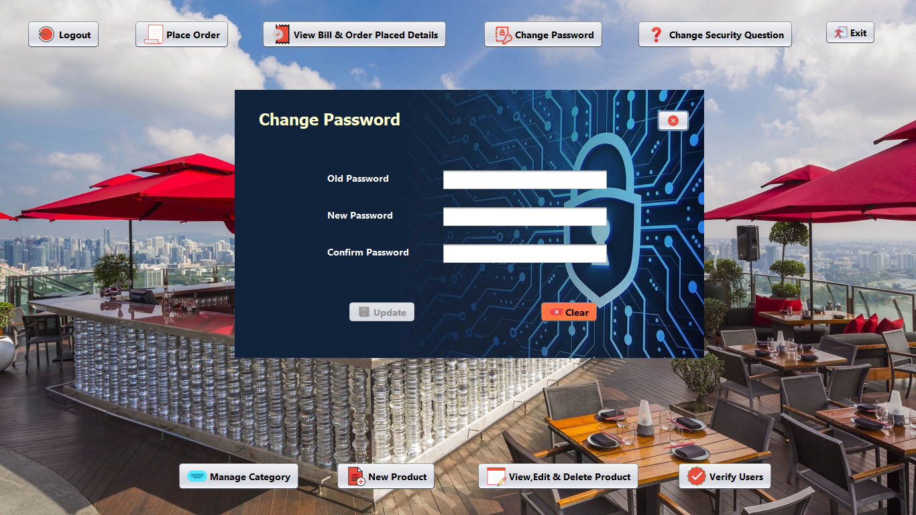

Figure No.:-10

**Change Password:-**

/*

* Click nbfs://nbhost/SystemFileSystem/Templates/Licenses/license-default.txt to change this license

* Click nbfs://nbhost/SystemFileSystem/Templates/GUIForms/JFrame.java to edit this template

*/

package cafe.management.system;

import dao.UserDao;

/**

*

* @author Amarjeet

*/

public class ChangePassword extends javax.swing.JFrame {

public String userEmail;

/**

* Creates new form ChangePassword

*/

public ChangePassword() {

initComponents();

}

public ChangePassword(String email) {

initComponents();

userEmail=email;

btnUpdate.setEnabled(false);

}

public void validateField()

{

String oldPassword=txtOldPassword.getText();

String newPassword=txtNewPassword.getText();

String confirmPassword=txtConfirmPassword.getText();

if(!oldPassword.equals("") && !newPassword.equals("") && !confirmPassword.equals("") && newPassword.equals(confirmPassword))

{

btnUpdate.setEnabled(true);

}

else

{

btnUpdate.setEnabled(false);

}

}

/**

* This method is called from within the constructor to initialize the form.

* WARNING: Do NOT modify this code. The content of this method is always

* regenerated by the Form Editor.

*/

@SuppressWarnings("unchecked")

// <editor-fold defaultstate="collapsed" desc="Generated Code">

private void initComponents() {

jLabel1 = new javax.swing.JLabel();

jButton1 = new javax.swing.JButton();

jLabel2 = new javax.swing.JLabel();

jLabel3 = new javax.swing.JLabel();

jLabel4 = new javax.swing.JLabel();

txtOldPassword = new javax.swing.JPasswordField();

txtNewPassword = new javax.swing.JPasswordField();

txtConfirmPassword = new javax.swing.JPasswordField();

btnUpdate = new javax.swing.JButton();

jButton3 = new javax.swing.JButton();

jLabel5 = new javax.swing.JLabel();

setDefaultCloseOperation(javax.swing.WindowConstants.EXIT_ON_CLOSE);

setLocation(new java.awt.Point(350, 134));

setUndecorated(true);

getContentPane().setLayout(new org.netbeans.lib.awtextra.AbsoluteLayout());

jLabel1.setFont(new java.awt.Font("Tahoma", 1, 24)); // NOI18N

jLabel1.setForeground(new java.awt.Color(255, 255, 204));

jLabel1.setText("Change Password");

getContentPane().add(jLabel1, new org.netbeans.lib.awtextra.AbsoluteConstraints(36, 29, -1, -1));

jButton1.setIcon(new javax.swing.ImageIcon(getClass().getResource("/image/close.png"))); // NOI18N

jButton1.addActionListener(new java.awt.event.ActionListener() {

public void actionPerformed(java.awt.event.ActionEvent evt) {

jButton1ActionPerformed(evt);

}

});

getContentPane().add(jButton1, new org.netbeans.lib.awtextra.AbsoluteConstraints(630, 30, -1, -1));

jLabel2.setFont(new java.awt.Font("Segoe UI", 1, 14)); // NOI18N

jLabel2.setForeground(new java.awt.Color(255, 255, 255));

jLabel2.setText("Old Password");

getContentPane().add(jLabel2, new org.netbeans.lib.awtextra.AbsoluteConstraints(138, 121, -1, -1));

jLabel3.setFont(new java.awt.Font("Segoe UI", 1, 14)); // NOI18N

jLabel3.setForeground(new java.awt.Color(255, 255, 255));

jLabel3.setText("New Password");

getContentPane().add(jLabel3, new org.netbeans.lib.awtextra.AbsoluteConstraints(138, 176, -1, -1));

jLabel4.setFont(new java.awt.Font("Segoe UI", 1, 14)); // NOI18N

jLabel4.setForeground(new java.awt.Color(255, 255, 255));

jLabel4.setText("Confirm Password");

getContentPane().add(jLabel4, new org.netbeans.lib.awtextra.AbsoluteConstraints(138, 231, -1, -1));

txtOldPassword.setFont(new java.awt.Font("Segoe UI", 1, 14)); // NOI18N

txtOldPassword.addKeyListener(new java.awt.event.KeyAdapter() {

public void keyReleased(java.awt.event.KeyEvent evt) {

txtOldPasswordKeyReleased(evt);

}

});

getContentPane().add(txtOldPassword, new org.netbeans.lib.awtextra.AbsoluteConstraints(309, 118, 248, -1));

txtNewPassword.setFont(new java.awt.Font("Segoe UI", 1, 14)); // NOI18N

txtNewPassword.addKeyListener(new java.awt.event.KeyAdapter() {

public void keyReleased(java.awt.event.KeyEvent evt) {

txtNewPasswordKeyReleased(evt);

}

});

getContentPane().add(txtNewPassword, new org.netbeans.lib.awtextra.AbsoluteConstraints(309, 173, 248, -1));

txtConfirmPassword.setFont(new java.awt.Font("Segoe UI", 1, 14)); // NOI18N

txtConfirmPassword.addKeyListener(new java.awt.event.KeyAdapter() {

public void keyReleased(java.awt.event.KeyEvent evt) {

txtConfirmPasswordKeyReleased(evt);

}

});

getContentPane().add(txtConfirmPassword, new org.netbeans.lib.awtextra.AbsoluteConstraints(309, 228, 248, -1));

btnUpdate.setBackground(new java.awt.Color(51, 255, 255));

btnUpdate.setFont(new java.awt.Font("Segoe UI", 1, 14)); // NOI18N

btnUpdate.setIcon(new javax.swing.ImageIcon(getClass().getResource("/image/save.png"))); // NOI18N

btnUpdate.setText("Update");

btnUpdate.addActionListener(new java.awt.event.ActionListener() {

public void actionPerformed(java.awt.event.ActionEvent evt) {

btnUpdateActionPerformed(evt);

}

});

getContentPane().add(btnUpdate, new org.netbeans.lib.awtextra.AbsoluteConstraints(169, 315, -1, -1));

jButton3.setBackground(new java.awt.Color(255, 102, 51));

jButton3.setFont(new java.awt.Font("Segoe UI", 1, 14)); // NOI18N

jButton3.setIcon(new javax.swing.ImageIcon(getClass().getResource("/image/clear.png"))); // NOI18N

jButton3.setText("Clear");

jButton3.addActionListener(new java.awt.event.ActionListener() {

public void actionPerformed(java.awt.event.ActionEvent evt) {

jButton3ActionPerformed(evt);

}

});

getContentPane().add(jButton3, new org.netbeans.lib.awtextra.AbsoluteConstraints(455, 315, -1, -1));

jLabel5.setIcon(new javax.swing.ImageIcon(getClass().getResource("/image/ChangePass.jpg"))); // NOI18N

getContentPane().add(jLabel5, new org.netbeans.lib.awtextra.AbsoluteConstraints(0, 0, -1, 400));

pack();

}// </editor-fold>

private void txtOldPasswordKeyReleased(java.awt.event.KeyEvent evt) {

// TODO add your handling code here:

validateField();

}

private void txtNewPasswordKeyReleased(java.awt.event.KeyEvent evt) {

// TODO add your handling code here:

validateField();

}

private void txtConfirmPasswordKeyReleased(java.awt.event.KeyEvent evt) {

// TODO add your handling code here:

validateField();

}

private void jButton1ActionPerformed(java.awt.event.ActionEvent evt) {

// TODO add your handling code here:

setVisible(false);

}

private void jButton3ActionPerformed(java.awt.event.ActionEvent evt) {

// TODO add your handling code here:

setVisible(false);

new ChangePassword(userEmail).setVisible(true);

}

private void btnUpdateActionPerformed(java.awt.event.ActionEvent evt) {

// TODO add your handling code here:

String oldPassword=txtOldPassword.getText();

String newPassword=txtNewPassword.getText();

UserDao.changePassword(userEmail, oldPassword, newPassword);

setVisible(false);

new ChangePassword(userEmail).setVisible(true);

}

/**

* @param args the command line arguments

*/

public static void main(String args[]) {

/* Set the Nimbus look and feel */

//<editor-fold defaultstate="collapsed" desc=" Look and feel setting code (optional) ">

/* If Nimbus (introduced in Java SE 6) is not available, stay with the default look and feel.

* For details see http://download.oracle.com/javase/tutorial/uiswing/lookandfeel/plaf.html

*/

try {

for (javax.swing.UIManager.LookAndFeelInfo info : javax.swing.UIManager.getInstalledLookAndFeels()) {

if ("Nimbus".equals(info.getName())) {

javax.swing.UIManager.setLookAndFeel(info.getClassName());

break;

}

}

} catch (ClassNotFoundException ex) {

java.util.logging.Logger.getLogger(ChangePassword.class.getName()).log(java.util.logging.Level.SEVERE, null, ex);

} catch (InstantiationException ex) {

java.util.logging.Logger.getLogger(ChangePassword.class.getName()).log(java.util.logging.Level.SEVERE, null, ex);

} catch (IllegalAccessException ex) {

java.util.logging.Logger.getLogger(ChangePassword.class.getName()).log(java.util.logging.Level.SEVERE, null, ex);

} catch (javax.swing.UnsupportedLookAndFeelException ex) {

java.util.logging.Logger.getLogger(ChangePassword.class.getName()).log(java.util.logging.Level.SEVERE, null, ex);

}

//</editor-fold>

/* Create and display the form */

java.awt.EventQueue.invokeLater(new Runnable() {

public void run() {

new ChangePassword().setVisible(true);

}

});

}

// Variables declaration - do not modify

private javax.swing.JButton btnUpdate;

private javax.swing.JButton jButton1;

private javax.swing.JButton jButton3;

private javax.swing.JLabel jLabel1;

private javax.swing.JLabel jLabel2;

private javax.swing.JLabel jLabel3;

private javax.swing.JLabel jLabel4;

private javax.swing.JLabel jLabel5;

private javax.swing.JPasswordField txtConfirmPassword;

private javax.swing.JPasswordField txtNewPassword;

private javax.swing.JPasswordField txtOldPassword;

// End of variables declaration

}

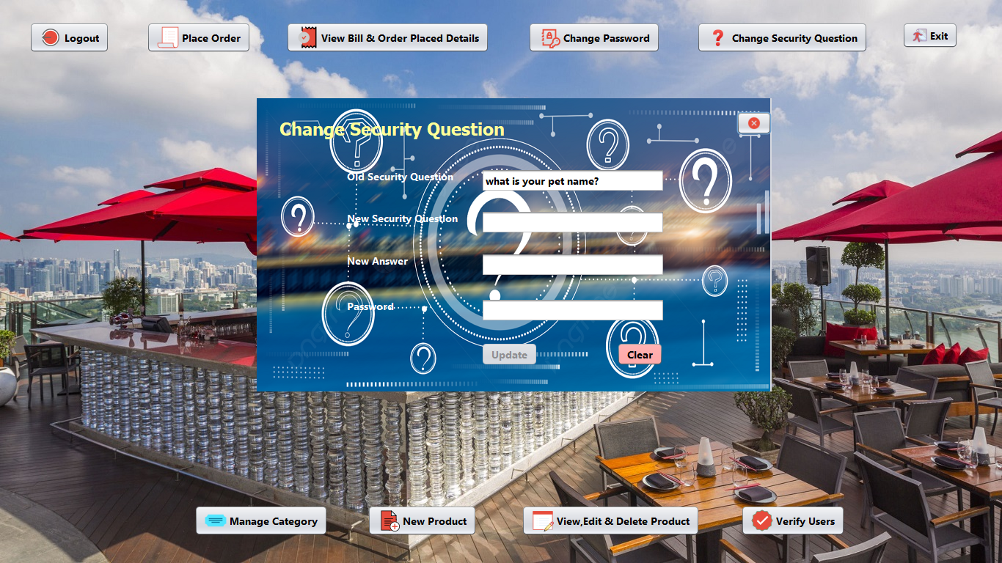

Figure No:-11

**Change Security Question:-**

/*

* Click nbfs://nbhost/SystemFileSystem/Templates/Licenses/license-default.txt to change this license

* Click nbfs://nbhost/SystemFileSystem/Templates/GUIForms/JFrame.java to edit this template

*/

package cafe.management.system;

import dao.UserDao;

import model.User;

/**

*

* @author Amarjeet

*/

public class ChangeSecurityQuestion extends javax.swing.JFrame {

public String userEmail;

/**

* Creates new form ChangeSecurityQuestion

*/

public ChangeSecurityQuestion() {

initComponents();

}

public ChangeSecurityQuestion(String email) {

initComponents();

userEmail=email;

txtOldSQ.setEditable(false);

btnUpdate.setEnabled(false);

}

public void validateField()

{

String password=txtPassword.getText();

String securityQuestion=txtNewSQ.getText();

String answer=txtNewAns.getText();

if(!password.equals("") && !securityQuestion.equals("") && !answer.equals(""))

{

btnUpdate.setEnabled(true);

}

else

btnUpdate.setEnabled(false);

}

/**

* This method is called from within the constructor to initialize the form.

* WARNING: Do NOT modify this code. The content of this method is always

* regenerated by the Form Editor.

*/

@SuppressWarnings("unchecked")

// <editor-fold defaultstate="collapsed" desc="Generated Code">

private void initComponents() {

jButton1 = new javax.swing.JButton();

jLabel1 = new javax.swing.JLabel();

jLabel2 = new javax.swing.JLabel();

txtOldSQ = new javax.swing.JTextField();

jLabel3 = new javax.swing.JLabel();

txtNewSQ = new javax.swing.JTextField();

jLabel4 = new javax.swing.JLabel();

txtNewAns = new javax.swing.JTextField();

jLabel5 = new javax.swing.JLabel();

txtPassword = new javax.swing.JPasswordField();

btnUpdate = new javax.swing.JButton();

jButton3 = new javax.swing.JButton();

jLabel6 = new javax.swing.JLabel();

setDefaultCloseOperation(javax.swing.WindowConstants.EXIT_ON_CLOSE);

setLocation(new java.awt.Point(350, 134));

setUndecorated(true);

addComponentListener(new java.awt.event.ComponentAdapter() {

public void componentShown(java.awt.event.ComponentEvent evt) {

formComponentShown(evt);

}

});

getContentPane().setLayout(new org.netbeans.lib.awtextra.AbsoluteLayout());

jButton1.setIcon(new javax.swing.ImageIcon(getClass().getResource("/image/close.png"))); // NOI18N

jButton1.addActionListener(new java.awt.event.ActionListener() {

public void actionPerformed(java.awt.event.ActionEvent evt) {

jButton1ActionPerformed(evt);

}

});

getContentPane().add(jButton1, new org.netbeans.lib.awtextra.AbsoluteConstraints(654, 18, -1, -1));

jLabel1.setFont(new java.awt.Font("Tahoma", 1, 24)); // NOI18N

jLabel1.setForeground(new java.awt.Color(255, 255, 153));

jLabel1.setText("Change Security Question");

getContentPane().add(jLabel1, new org.netbeans.lib.awtextra.AbsoluteConstraints(31, 27, -1, -1));

jLabel2.setFont(new java.awt.Font("Segoe UI", 1, 14)); // NOI18N

jLabel2.setForeground(new java.awt.Color(255, 255, 255));

jLabel2.setText("Old Security Question");

getContentPane().add(jLabel2, new org.netbeans.lib.awtextra.AbsoluteConstraints(123, 96, -1, -1));

txtOldSQ.setFont(new java.awt.Font("Segoe UI", 1, 14)); // NOI18N

getContentPane().add(txtOldSQ, new org.netbeans.lib.awtextra.AbsoluteConstraints(306, 96, 250, -1));

jLabel3.setFont(new java.awt.Font("Segoe UI", 1, 14)); // NOI18N

jLabel3.setForeground(new java.awt.Color(255, 255, 255));

jLabel3.setText("New Security Question");

getContentPane().add(jLabel3, new org.netbeans.lib.awtextra.AbsoluteConstraints(123, 153, -1, -1));

txtNewSQ.setFont(new java.awt.Font("Segoe UI", 1, 14)); // NOI18N

txtNewSQ.addKeyListener(new java.awt.event.KeyAdapter() {

public void keyReleased(java.awt.event.KeyEvent evt) {

txtNewSQKeyReleased(evt);

}

});

getContentPane().add(txtNewSQ, new org.netbeans.lib.awtextra.AbsoluteConstraints(306, 153, 250, -1));

jLabel4.setFont(new java.awt.Font("Segoe UI", 1, 14)); // NOI18N

jLabel4.setForeground(new java.awt.Color(255, 255, 255));

jLabel4.setText("New Answer");

getContentPane().add(jLabel4, new org.netbeans.lib.awtextra.AbsoluteConstraints(123, 211, -1, -1));

txtNewAns.setFont(new java.awt.Font("Segoe UI", 1, 14)); // NOI18N

txtNewAns.addKeyListener(new java.awt.event.KeyAdapter() {

public void keyReleased(java.awt.event.KeyEvent evt) {

txtNewAnsKeyReleased(evt);

}

});

getContentPane().add(txtNewAns, new org.netbeans.lib.awtextra.AbsoluteConstraints(306, 211, 250, -1));

jLabel5.setFont(new java.awt.Font("Segoe UI", 1, 14)); // NOI18N

jLabel5.setForeground(new java.awt.Color(255, 255, 255));

jLabel5.setText("Password");

getContentPane().add(jLabel5, new org.netbeans.lib.awtextra.AbsoluteConstraints(123, 273, -1, -1));

txtPassword.setFont(new java.awt.Font("Segoe UI", 1, 14)); // NOI18N

txtPassword.addKeyListener(new java.awt.event.KeyAdapter() {

public void keyReleased(java.awt.event.KeyEvent evt) {

txtPasswordKeyReleased(evt);

}

});

getContentPane().add(txtPassword, new org.netbeans.lib.awtextra.AbsoluteConstraints(306, 273, 250, -1));

btnUpdate.setBackground(new java.awt.Color(0, 204, 51));

btnUpdate.setFont(new java.awt.Font("Segoe UI", 1, 14)); // NOI18N

btnUpdate.setText("Update");

btnUpdate.addActionListener(new java.awt.event.ActionListener() {

public void actionPerformed(java.awt.event.ActionEvent evt) {

btnUpdateActionPerformed(evt);

}

});

getContentPane().add(btnUpdate, new org.netbeans.lib.awtextra.AbsoluteConstraints(306, 333, -1, -1));

jButton3.setBackground(new java.awt.Color(255, 153, 153));

jButton3.setFont(new java.awt.Font("Segoe UI", 1, 14)); // NOI18N

jButton3.setText("Clear");

jButton3.addActionListener(new java.awt.event.ActionListener() {

public void actionPerformed(java.awt.event.ActionEvent evt) {

jButton3ActionPerformed(evt);

}

});

getContentPane().add(jButton3, new org.netbeans.lib.awtextra.AbsoluteConstraints(491, 333, -1, -1));

jLabel6.setIcon(new javax.swing.ImageIcon(getClass().getResource("/image/seq.jpg"))); // NOI18N

getContentPane().add(jLabel6, new org.netbeans.lib.awtextra.AbsoluteConstraints(0, 0, 700, 400));

pack();

}// </editor-fold>

private void jButton1ActionPerformed(java.awt.event.ActionEvent evt) {

// TODO add your handling code here:

setVisible(false);

}

private void formComponentShown(java.awt.event.ComponentEvent evt) {

// TODO add your handling code here:

User user=UserDao.getSecurityQuestion(userEmail);

txtOldSQ.setText(user.getSecurity());

}

private void txtNewSQKeyReleased(java.awt.event.KeyEvent evt) {

// TODO add your handling code here:

validateField();

}

private void txtNewAnsKeyReleased(java.awt.event.KeyEvent evt) {

// TODO add your handling code here:

validateField();

}

private void txtPasswordKeyReleased(java.awt.event.KeyEvent evt) {

// TODO add your handling code here:

validateField();

}

private void btnUpdateActionPerformed(java.awt.event.ActionEvent evt) {

// TODO add your handling code here:

String password=txtPassword.getText();

String securityQuestion=txtNewSQ.getText();

String answer=txtNewAns.getText();

UserDao.changeSecurityQuestion(userEmail, password, securityQuestion, answer);

setVisible(false);

new ChangeSecurityQuestion(userEmail).setVisible(true);

}

private void jButton3ActionPerformed(java.awt.event.ActionEvent evt) {

// TODO add your handling code here:

setVisible(false);

new ChangeSecurityQuestion(userEmail).setVisible(true);

}

/**

* @param args the command line arguments

*/

public static void main(String args[]) {

/* Set the Nimbus look and feel */

//<editor-fold defaultstate="collapsed" desc=" Look and feel setting code (optional) ">

/* If Nimbus (introduced in Java SE 6) is not available, stay with the default look and feel.

* For details see http://download.oracle.com/javase/tutorial/uiswing/lookandfeel/plaf.html

*/

try {

for (javax.swing.UIManager.LookAndFeelInfo info : javax.swing.UIManager.getInstalledLookAndFeels()) {

if ("Nimbus".equals(info.getName())) {

javax.swing.UIManager.setLookAndFeel(info.getClassName());

break;

}

}

} catch (ClassNotFoundException ex) {

java.util.logging.Logger.getLogger(ChangeSecurityQuestion.class.getName()).log(java.util.logging.Level.SEVERE, null, ex);

} catch (InstantiationException ex) {

java.util.logging.Logger.getLogger(ChangeSecurityQuestion.class.getName()).log(java.util.logging.Level.SEVERE, null, ex);

} catch (IllegalAccessException ex) {

java.util.logging.Logger.getLogger(ChangeSecurityQuestion.class.getName()).log(java.util.logging.Level.SEVERE, null, ex);

} catch (javax.swing.UnsupportedLookAndFeelException ex) {

java.util.logging.Logger.getLogger(ChangeSecurityQuestion.class.getName()).log(java.util.logging.Level.SEVERE, null, ex);

}

//</editor-fold>

/* Create and display the form */

java.awt.EventQueue.invokeLater(new Runnable() {

public void run() {

new ChangeSecurityQuestion().setVisible(true);

}

});

}

// Variables declaration - do not modify

private javax.swing.JButton btnUpdate;

private javax.swing.JButton jButton1;

private javax.swing.JButton jButton3;

private javax.swing.JLabel jLabel1;

private javax.swing.JLabel jLabel2;

private javax.swing.JLabel jLabel3;

private javax.swing.JLabel jLabel4;

private javax.swing.JLabel jLabel5;

private javax.swing.JLabel jLabel6;

private javax.swing.JTextField txtNewAns;

private javax.swing.JTextField txtNewSQ;

private javax.swing.JTextField txtOldSQ;

private javax.swing.JPasswordField txtPassword;

// End of variables declaration

}

**Module Description**

**Login Module:-**

This module takes the user authentication and allows the user to proceed further if the validation is correct, else repeat the process maximum three times or terminate the user id & Password is not correct.

**MDI Main Module:-**

This project consist a main form module which provide the link to all other module from the help of its menus, basically this is MDI application form module and all others module having child of this.

**Tools Languages Used**

**Application :-**  Database Management

**Front End :-** Java Swing

**Back End :-** Mysql Server

**System Environment**

**Processor :-** Intel i5 Processor ( 1.30 GHz)

**RAM :-** 8GB

**Operating System:-**Window 2011 , Window 9x

**Database :-** Mysql workbench 8.0

**Further scope of the project**

This project is applicable to many real world problem.

Because most of the customer use the restaurant and the Admin need to maintain the record of each details.

This make user to maintain record of the details and the customer record easily and to update records.

It the user forgot the details he taken from the restaurant you can remind him/her by looking their Bill in which date, name of the Details admin.

**Conclusion**

We were able to create a computerized system for silk route to maintain billing & Restaurant records. This system is able to store billing records securely and retrieve the records whenever needed easily. Data entering of customers and admin are also included in this system along with the order and the billing process. Customers, restaurant records and are interconnected in order to maintain the accuracy of the system . this system can also be further improved adding many other features and including the other systems as well. Finally we believe that we were able to lunch an effective computerized system to the restaurant causing the restaurant to perform well in the future regarding the billing and restaurant records.

**References**

* + - Book(Complete Reference in java).
    - YouTube (Apna College Channel).
    - Google.

*****************THE END*****************